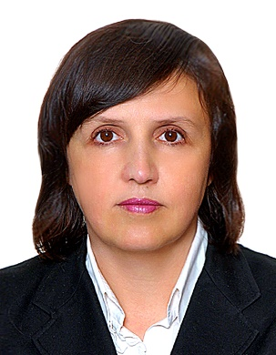 | Associate professor Natalia A. Narotskaia  Dr. of Science (Economics), Associate professor, Department of World Economy, Faculty of Economics, Saint Petersburg State University, Saint Petersburg, Russia  Навроцкая Наталья Анатольевна,  доктор экономических наук, доцент, доцент кафедры мировой экономики, Санкт-Петербургский государственный университет, Санкт-Петербург, Россия
Academic Profile
Natalia A. Narotskaia
Dr. of Science (Economics), Associate professor, Department of World Economy, Faculty of Economics, Saint Petersburg State University (SPSU), Saint Petersburg, Russia
ORCID ID: 0000-0002-0213-6863
Researcher ID: A-1948-2016
Scopus Author ID: 56157404600
eLibrary: SPIN-код: 1733-7958, AuthorID: 670802
Education and Academic Degrees
Graduated from the Dnepropetrovsk State University, 1994, economics
Doctor of Science (Economics) (2015)
Associate Professor (2012)
Research Interests
- International Finance and Investment
- International trade
- Multinational Corporations
- Theory and Practice of International Business
Scientific Research Impact
h-index (Scopus / WoS / RSCI): 2 / 1 / 5
Selected Publications
- Sopilko, N. Y., Navrotskaia, N. A. E., Kovaleva, E. A., Orlova, A. F., & Grigoryeva, A. V. (2017). Dynamics factors and slow-response characteristics of Russian trade ties // Journal of Advanced Research in Law and Economics. 2017. 8(2 (24)), Pp. 625-634.
- Navrotskaia N. A., E.A. Kovaleva E.A., E.V. Zenkina E.V., G.M. Kutlyeva G.M., Bogacheva T.V., Bondarchuk N.V. Technological Cooperation Trends Under Conditions of the Modern World Economy // International Journal of Engineering & Technology Vol 7, No 3.15 (2018), pp. 288-292
DOI: 10.14419/ijet.v7i3.15.18690
- Navrotskaia, N. A., Sopilko N.Yu., Kutlyeva G.M., Lysytska S.M. Modeling the International-Trade Network: a Cointegration Approach // The Turkish Online Journal of Design, Art and Communication (TOJDAC), SEPTEMBER 2018, DOI: 10.7456/1080SSE
- Navrotskaia N. A. Globalization of the investment process. Dnepropetrovsk: Lira. 2014. (in Ukrainian)
Selected International Conferences
- N.A. Navrotskaia, N.Yu. Sopilko, G.M. Kutlyeva, S.M. Lysytska Analysis of International Trade Based on Complex Networks In The 2-nd International Congress of Scientists 2018. Moscow, Russia. Program and Collected Abstracts. Moscow, Russia, May 03-05, 2018.
Doctorate Consultation and PhD Student Supervision
2 dissertations
Grants and Scholarships
Participant of the grant project «China's Foreign Economic Policy: Challenges and Opportunities for Countries» (2017-2018) St. Petersburg State University
Editorial Board Membership
Refereed Journals:
- «International Journal of Economics, Finance and Management Sciences» (USA) (editorial member)
Contact Information
Tel.: office: (+7 812) 363-67-67 ; mob: (+7 931) 373-44-03
E-mail: < n.navrotskaya@spbu.ru > < nawrozkaya@mail.ru >
Web:
15 сентября 2018 г.

