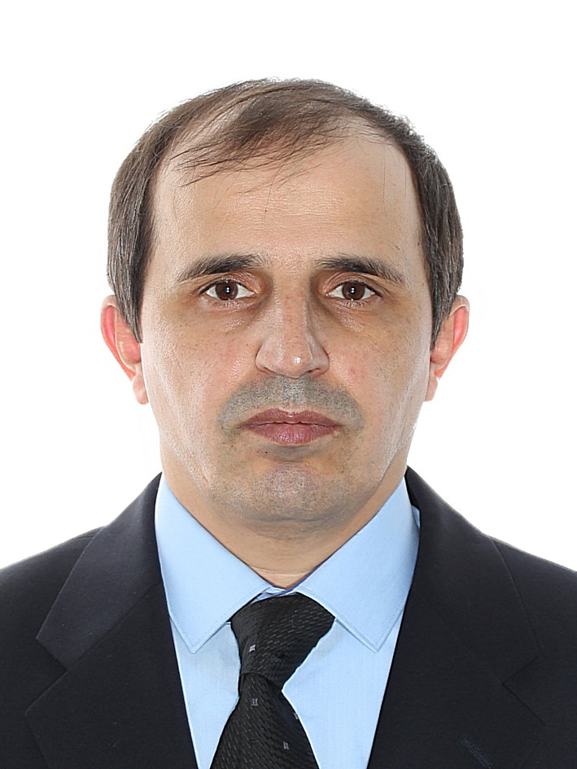 | Associate professor Magomed D. Aliev  Ph.D. in Economics, Associate professor, Department of World Economy, Faculty of Economics, Saint Petersburg State University, Saint Petersburg, Russia  Алиев Магомед Далгатович,  кандидат экономических наук, доцент кафедры мировой экономики, Санкт-Петербургский государственный университет, Санкт-Петербург, Россия

Academic Profile
Magomed D. Aliev
Ph.D. in Economics, Associate professor, Department of World Economy, Faculty of Economics, Saint Petersburg State University (SPSU), Saint Petersburg, Russia
ORCID ID: 0000-0001-9966-9190
Researcher ID: T-6281-2017
eLibrary: SPIN-код: 3523-6677, AuthorID: 535652
Education and Academic Degrees
Dagestan state pedagogical University, 1998, teacher
National Humanities Institute at St. Petersburg state University, 2001, economics
St. Petersburg state agrarian University, 2006, lawyer
Ph.D. in Economics, 2011
Research Interests
- International labour migration, international labour markets
- Economy of Islam
- International tourism
Scientific Research Impact
h-index (Scopus / WoS / RSCI): 0 / 0 / 3

Selected Publications
- The impact of international migration on socio-economic development of Russia // The Employment and economic growth / K. Pissarides, O. L. Margania, S. A. Belozerov. – SPb.: Publishing House of St. Petersburg. university, 2018. -306 p.
- Russia in the system of international migration processes. (monograph)// Monograph. – SPb.: Publishing house Spbguse, 2011.-175 p.
- The theory of multiple labor markets (article) / / Journal of legal and economic research. 2013. No. 1. P. 148-149.
- The impact of the digital economy on the world labor market // International economy. - 2018. - №03. - P. 39-43.
- Illegal migration in Russia and the USA: comparative analysis // "Economic theory and economic practice: global challenges" Proceedings of the international conference "Evolution of the international trading system: problems and prospects — 2017" Scythia-Print publishing House. SPb, 2017
- On the issue of determining the coefficient of tolerance in migration processes (article) / / Russian economic Internet journal [Electronic resource]: Internet journal Atiso / Acad. labor and social. relations-Electron.journal. - M.: Atiso, 2002 -. - state registration no. 0420600008. - Access mode: http://www.e-rej.ru/Articles/2010/Aliev1.pdf free-Zagl. 9 PP
Selected International Conferences
- International conference "Evolution of the international trading system: problems and prospects", 2015-2018 St. Petersburg
- International scientific and practical conference "New trends and consequences of migration in the context of geopolitical and economic crises" 31 October 2016 Moscow / 2017,2018
- St. Petersburg international youth labour forum,St. Petersburg, 2017-2018
- St. Petersburg international Forum of Labor, Saint-Petersburg, 2017-2019
Contact Information
Tel.: office: (+7 812) 363-67-67 ; mob: (+7 921) 754-99-12
E-mail: < m.aliev@spbu.ru > < myrad@inbox.ru >
Web:

