Saint-Petersburg State University
Faculty of Economic Science

International Trade in Diamonds

Prepared by 1st year Master students of
International Trading System program
Ivanova Vlada
Kozakeivch Tatiana

Saint-Petersburg
2020
Structure of the industry
The diamond market is conventionally divided into three segments:
- Industrial Diamonds—natural and synthetic diamonds that are used in a wide range of manufacturing processes for their physical properties;
- Jewelry Diamonds—rough diamonds cut for use as gemstones in jewelry;
- Investment Diamonds—high-quality large gemstones, often with special characteristics, purchased for investment;
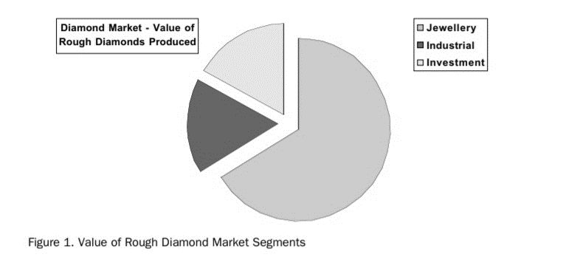
Source: Chang, S.-Y. The Global Diamond Industry.
The Jewelry and Investment segments together represent 83 percent of the value of rough diamonds produced (Chang, 2002).
Global value chain (GVC) can be classified into three categories (Kumar, 2020):
- upstream (e.g. exploration and production);
- midstream (e.g. cutting, polishing, and valuing);
- downstream (e.g. jewelry designing and manufacturing).
But sometimes a category connected with rough diamond distribution might be included.
The global industry remains ruled by powerful cartels, close-knit or family communities. For instance, Hasidic families have stayed the backbone of the world gemstones industry for a long time, first in Amsterdam, later in Antwerp and finally in Tel Aviv. The global diamond industry is characterized by export orientation, high demand elasticity and a community-based business model (Kumar, 2020). Such business models may compensate for such socio-economic issues as lack of education or access to finances, business failures and facilitate informal settlements of disputes. However, an absence of monitoring and assessing the mining and exploration process leads to social controversies and conflicts. Besides, the transnational existence of such communities as the Jews in Brooklyn or the Jains and the Patels in Antwerp ensures enormous significance of international cluster relations and networking. Nevertheless, the competitive advantage in the industry is changing over the past two decades. As a result of the greater global attention to rogue governance and corruption and the following decline in the monopolistic power and influence of cartels, the upstream value chain has subjected to many shifts.
Measurement of the diamond’s value
The measurement of the value and quality of diamonds is based on the 4Cs – globally accepted standard for describing diamonds – cut, clarity, color and carat weight. With evolvement of synthetic diamonds, the issue of differentiating synthetic diamonds from natural diamonds became urgent. The management and potential penetration of synthetic diamonds is regulated by the 4Ds - Differentiation, Detection, Disclosure and Documentation. The 4Ds are reliant on each other and without them product differentiation between synthetic and natural diamonds is not possible (Grynberg, 2014).
It is necessary to mention that in the market diamonds are priced per unit of weight - “per carat." One carat equals 0.2 or 1/5 of a gram, which means 5 carats equals 1 gram. The price of a 1 carat diamond is between $1,300 and $16,500, depending on factors such as the diamond’s cut quality, clarity, color and shape. Average price per carat broken down by carat weight significantly ranges (Table 1).
Table 1. Average price per carat broken down by carat weight ranges
Weight Range | Average price / carat
Less than 0.5 ct | 2,348$
0.51 - 0.99 ct | 3,586$
1.00-1.49 ct | 5,589$
1.50-1.99 ct | 7,472$
2.00-2.99 ct | 9,825$
3.00-3.99 ct | 13,960$
4.00-4.99 ct | 16,672$
5.00 and more ct | 23,737$
Source: The auction house of the Russian Federation. 2020.
Main players
In the upstream value chain, the process of the diamond recovery is dominated by eight states – Republic of Botswana, Russia, Canada, Angola, South Africa, Democratic Republic of Congo, Namibia and Australia, and is controlled by a few companies such as De Beers, Alrosa, Rio Tinto and others. Most of the world diamond reserves are concentrated in Russia, which represents the largest producer of rough diamonds by volume. Russia declared diamonds to be of strategic importance and all mining companies and their exploration processes are, at least partly, state-owned with free access to all country regions (Jotanovic, 2019). However, the exploration conditions are exceptionally severe and, thus, a huge part of these resources remains undeveloped. Africa has the largest proportion of estimated diamond resources that may be explored in the future. The sector of mining sector is the stage of the diamond industry value chain that has been delivering the highest profit margins.
The midstream value chain is mainly controlled by six countries: Belgium, Israel, India, Great Britain, the USA and Hong Kong (Kumar, 2020). Concerning main world suppliers, the diamond industry experienced a lot of transformations in the period of 1995–2017. Belgium was the world leader till 2005, Israel excelled Belgium and remained the leading exporter globally until 2008 and India surpassed them in 2009. One curious shift over this period is in the extraordinary rise of Hong Kong after 2009. Israel and Great Britain witnessed a dramatic decline in total exports since 2014. Several breaks such as value chain integration, the enhancement of modern technologies are altering the business model and dynamics of the industry, and such states as the US and Hong Kong are achieving significant share in global exports. It should be noted that India and Hong Kong produce small and less expensive gems (below one carat), whereas Israel specialises in medium-sized high carat diamonds, the US focuses on high-quality diamonds for investment purposes and Belgium manufactures all types of medium and large gems.
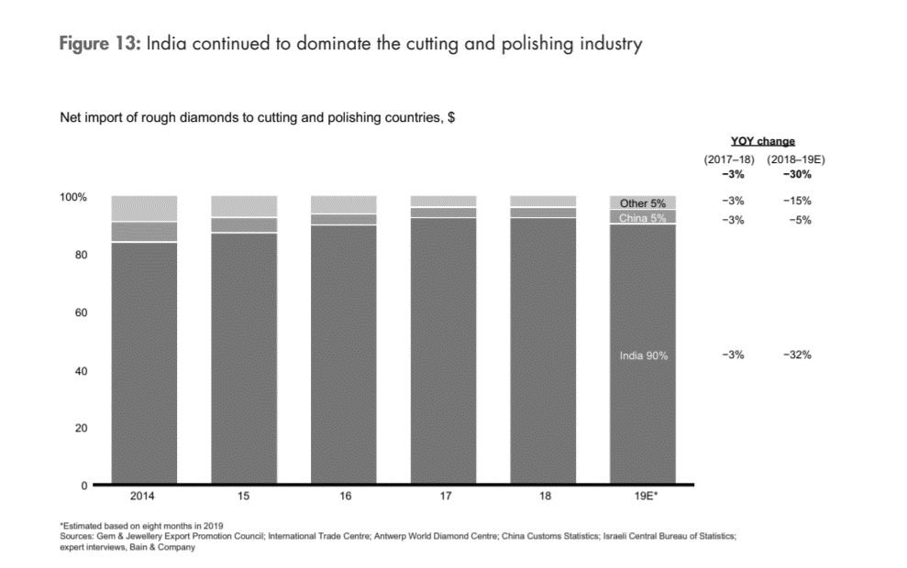
Source: Bain & Company. The Global Diamond Industry 2019.
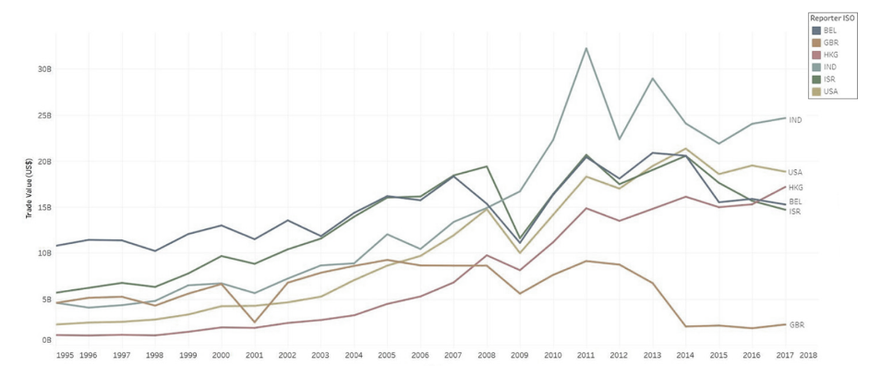
Source: Kumar, S. Impact of community-based business model and competitive advantage on exports: evidence from diamond industry.
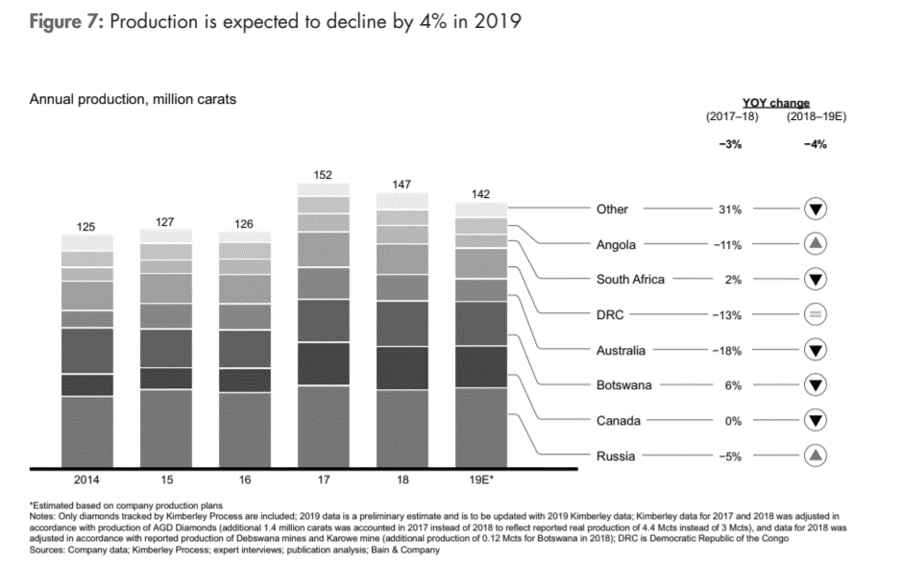
Source: Bain & Company. The Global Diamond Industry 2019.
Despite the fact that many international and local companies are involved in the diamond exploration and mining industry, the market is driven by the several top industry players: Alrosa, De Beers, Rio Tinto, Petra Diamonds and Dominion Diamond. The five leading companies accrued 78% of the industry’s revenues in 2012. Alrosa is the largest diamond volume producer, based on the number of diamond carats produced. De Beers, who had the monopoly of the industry until 2003, is now owned by Anglo-American and remains the largest rough diamond producer in value terms as shown. This advantage is not unattainable for others, as several competitors are approaching the levels of De Beers’ diamond value sales. For instance, De Beers in 2012 held 37% of the overall rough diamond value sales, while Alrosa’s share of the market was 30% (Jotanovic, 2019).
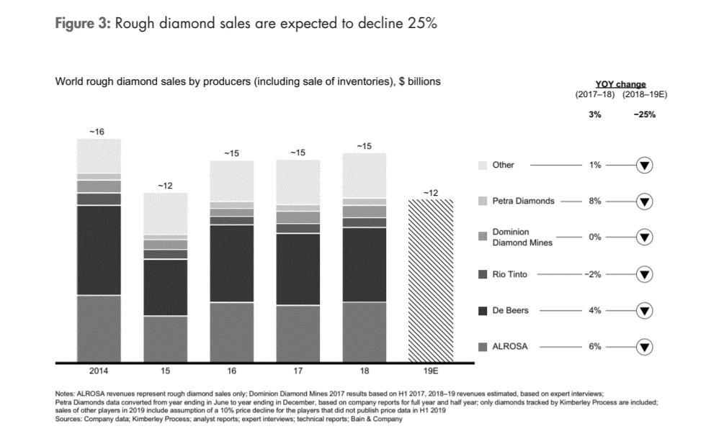
Source: Bain & Company. The Global Diamond Industry 2019.
In 1994 Namibia signed a 50–50 partnership with De Beers that would be renewed every five years (Munier, 2016). Furthermore, De Beers also changed the name of its diamond-mining operations in Namibia to Namdeb, to reflect the joint agreement between De Beers and the Namibian state. De Beers has a clear influence over political decision-making in Namibia, given its centrality to the economy. It is also important to point out that since the beginning of the Kimberley Process, De Beers has been very influential in the agreement. In fact, some observers have argued that De Beers is more influential than the states in the process and that the agreement is a public provision of a private good.
Since De Beers started its activity in Namibia, the transnational company has had the ability to restrict the potential policy decisions of politicians, and this influence exists today. A way of splitting profit between the authorities and De Beers is not public and important aspects of Namdeb’s relationship with the government are kept secret. Unlike the case of Botswana, Namibia does not hold direct shares in De Beers, however, there are representatives from the Namibian government on the board of directors. For Namdeb, the board of directors is also split 50–50 with six being appointed by the government and the other six by De Beers (Munier, 2016). Also, it might be pointed out that Namibian diamonds are worth more per unit than those of any other country, with Angola coming a rather distant second.
ALROSA
It is necessary to overview the largest Russian diamond mining company ALROSA more
in-depth way. As it was already mentioned, most of the world diamond reserves are concentrated in Russia and accounted for 45% of total number, which is approximately 628 million carats. ALROSA’s main production capacities are concentrated in Russia, in the Republic of Sakha (Yakutia) where nearly 90% of company’s assets are concentrated. The second largest with ALROSA’s assets region is Arkhangelsk region, which account for 10% of total company’s assets. In addition, ALROSA owns 41% of Angolan company Catoca Ltd. Mining Company, which allows it to operate, mine and explore rough diamonds in the Catoca mine, which is the fourth largest diamond mine in the world (ALROSA, 2019).
Let’s consider GVC more precisely using the example of ALROSA.
Stage 1. Mining
ALROSA uses advanced machinery in all our open-pit mines (ALROSA, 2020). These include excavators, drill rigs, and loaders, of both Russian and foreign makes. The ore (kimberlite) is extracted by blasting, then transported to a processing plant by supersize mine trucks (with a capacity of up to 136 tonnes). After coarse reduction in jaw or cone crushers the diamond-bearing ore is fed into drum mills for wet milling. Lumps of ore of up to 1.5 metres in size are reduced to 0.5 metres and smaller.
Stage 2. Ore Treatment and Concentration
Mid-sized material is processed in jigging machines and dense media separation (DMS) units. Pulsating water jets separate the diamonds from the slurry. Smaller-sized material, together with water-soluble flotation agents, go into a froth flotation machine where small-size diamonds stick to froth bubbles, and are carried to the final concentration stage. Large-size material is processed by X-ray fluorescent separation (based on the principle that diamonds fluoresce in X-rays). In the final recovery unit, diamonds are cleaned, sieved, handpicked, roughly sorted, and packed into containers.
Stage 3. Diamond sorting and marketing
Rough diamonds, originating from different ALROSA mines in Yakutia, are transported to Mirny. Here they are given a preliminary sorting into size categories, and also receive a preliminary valuation. Next, the diamonds are sent to the company’s United Selling Organization (USO) in Moscow. All stones are classified into 16 size and weight categories, according to international standards.
Diamonds in the large size and weight categories are exclusively hand sorted. To sort medium and small stones, the company uses vibration tables (to sort by weight) and optical systems (for colour). At this point of pre-sale preparation, diamonds from different mines are mixed and boxed by categories. ALROSA then sells rough stones to Russian-resident and foreign-based diamond manufacturers and wholesalers, both under long-term contracts, and also by tender.
Stage 4. Diamond manufacturing techniques
Diamond manufacturing techniques include planning (or marking), sawing, bruting, faceting and polishing. Most operations are manual. Robots and semi-automatic machines are only used for manufacturing cheaper and smaller diamonds.
Company’s Moscow-based Brillianty ALROSA (ALROSA Brilliants) cutting and polishing division produces stones of 4-6 grams and above. These are cut and polished into round or fancy shapes, across the entire range of size and weight categories. Smaller stones are cut and polished at ALROSA subsidiaries in Central Russia, in Barnaul and Orel.
Sales policy
The core of the Company's sales policy is long-term (three-year) supply agreements with the world's largest consumers of rough diamonds. ALROSA entered into such agreements with a number of companies from Russia, Belgium, India, Israel and Hong Kong SAR, PRC. These companies are major manufacturers of polished diamonds and jewelry, with proven solvency and competence and well-organized sales systems. Minimum volumes and assortments of monthly supply, as well as an option to adjust, by mutual agreement, the volumes and purchase an extra range of goods not stipulated by the agreement, are guaranteed for them. The major activities of this group of buyers are manufacturing and sales of polished diamonds and diamond jewelry.
Also, ALROSA trades in rough diamonds, based on one-time sales and purchase transactions, without concluding fixed-term supply agreements. In this case, the buyers can be Russian companies registered with the territorial inspectorates of assay supervision and entitled under the laws of the Russian Federation to deal in gemstones, as well as the companies registered outside the Russian Federation in the Kimberley Process member countries and entitled under the laws of those countries to deal in gemstones.
Large rough diamonds of +10.8 carats are sold exceptionally at auctions. The buyers who are the Company's partners under long-term agreements and one-time sale contracts, as well as other customers, who meet the minimum requirements, can participate in tenders and auctions. In 2011 ALROSA has launched a new form of rough diamond trade – online electronic auctions.
De Beers Sales
De Beers sells its rough diamonds through two channels: Global Sightholder Sales and Auctions. Global Sightholder Sales is an organization which sells rough diamonds via term contracts to customers known as Sightholders, at events called Sights, and Accredited Buyers. Sightholders benefit from a term contract covering the sale of diamonds over an agreed period, whereas Accredited Buyers have a more ad hoc arrangement (De Beers Group, 2020).
Sightholders are the world’s leading diamantaires and active in the diamond centers in New York, Antwerp, Tel Aviv, Mumbai and others. Sights are held 10 times a year in Botswana, Namibia and South Africa, where customers have an opportunity to probe their rough diamond allocations before deciding whether to purchase them. The majority of Global Sightholder Sales' rough diamonds are sold from Gaborone in Botswana to customers that will then export them to international markets for processing. In addition, the network of Sightholder sales operations sells 90% by value of De Beers Group’s available supply of rough diamonds (De Beers Group, 2020).
The significant issue of De Beer’s sales is the policy of diamond beneficiation. The beneficiation “is the process of adding value within producer countries and is the way De Beers Group works with its government partners to ensure that, beyond mining, as many of the diamond processing stages as possible take place in the producer country” (De Beers Group, 2020). To sum up, this process is aimed at providing support to De Beer’s partner countries by allocating the cutting and polishing processes to these countries, which would ensure the development of downstream diamond industries in these countries. It worth to mention, that Global Sightholder Sales sells diamonds to Botswana, Canada, Namibia and South Africa in order to ensure purposes of beneficiation.
Also, De Beers sells rough diamonds through Group Auctions. De Beers Group Auctions is a global business with headquarters in Singapore, and regional offices in Belgium, Israel, India and Hong Kong (SAR of China). 950 customers, ranging from diamond traders to manufacturers to retailers, buy diamonds through De Beers Auctions. It worth to mention that 10% of De Beers Group’s Rough diamond production by value is purchased, prepared and sold by De Beers Group Auctions (De Beers Group Auctions, 2020).
Import of diamonds
In 2018, the total diamond world imports accounted for 116 billion dollars. The main countries-importers of diamonds are India ($24.9 billion), United States ($20.2 billion), Hong Kong ($19.6 billion), Belgium-Luxembourg ($16.4 billion) and United Arab Emirates ($11.1 billion). Among other countries are Israel, Switzerland, Thailand, China, Japan, Singapore and etc (OEC, 2018).
We could suppose that abovementioned countries are the largest importers because there are located the major international centres of diamond exchanges (hubs). These exchanges are places which put together dealers, brokers and manufacturers who buy or sell diamonds. The essential principles of diamond hubs structure are the following:
- The large centres of mining and processing of diamonds;
- Historically developed shopping centres, near major ports;
- Developed capital market;
- Modified tax and customs regimes (Free Economic Zones);
- The concentration of skilled and inexpensive manpower.
Among the world’s major diamond centres are centres in Belgium, India, the United Arab Emirates, Israel and etc. The Belgium city Antwerp is considered as the most important centre of the diamond business. Through the Antwerp diamond exchanges pass about 80% of all diamonds that are processed and sold in the world. In India, one of the largest diamond exchanges in the world is located in Mumbai. Exchange centres operating in India provide enterprises tax and customs preferences within the limits of Free Economic Zones because of the policy of Indian government, which abolished all customs duties on imports of diamonds into the country. Also, the Dubai Diamond Exchange in Emirates is considered as one of the major world's centers of trading of rough and cut diamonds. As in India, the government of the UAE established a Free Economic Zone for enterprises operating there. Finally, we would like to mention that in Israel diamond industry is, also, highly supported by the government, which abolished duties on imports and exports of rough diamonds. The main Israel Diamond Exchange is located in Ramat Gan (Auction House, 2020).
Value Chain
As it was mentioned previously the global value chain of diamonds consists from the three major steps: exploration and production of rough diamonds; cutting and polishing of rough diamonds; jewelry designing and manufacturing. The added-value varies in every segment of the diamond industry and more precisely it increases at every step of the whole industry from the mining and exploration to the final market when diamonds are sold by retail companies. The largest value – approximately 25 billion dollars – is added at the stages of jewelry manufacturing and retail sales. According to the data, exploration and production of rough diamonds generates revenue of
14 billion dollars. At the second stage, when diamonds are cut and polished, the added-value increases by nearly 25% and the generated revenue accounts for 20.7 billion dollars. When jewelry is designed and manufactured and after sold by retail companies, the generated value constitutes
72 billion dollars (Bain & Company, 2013).
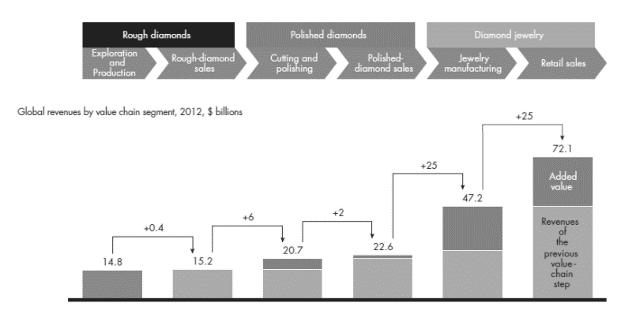
Source: Bain & Company. The Global Diamond Industry 2013: Journey through the Value Chain.
In addition, it seems significant to mention how the number of players and bargaining power varies across the diamond value chain. At first, the production of rough diamonds is concentrated around top 5 players whose bargaining power is really high. The sector of polished diamonds is concentrated around 5 000 players whose bargaining power is characterized as low. The number of players which design and manufacture jewelry is bigger than 10 000 players and as in the sector of cutting and polishing diamonds theirs barraging power is not high. In the retail sales, retailers control nearly 35% of the market and have medium bargaining power (Bain & Company, 2019).
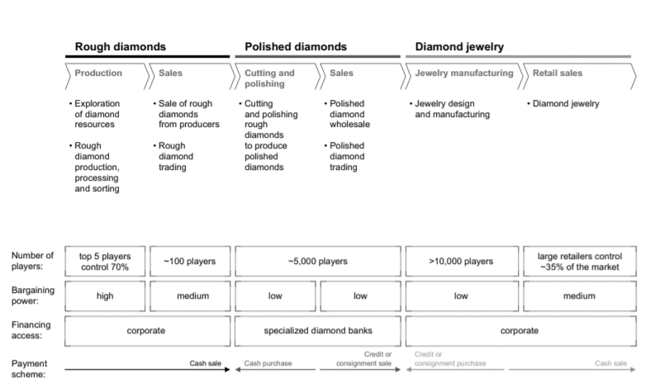
Source: Bain & Company. The Global Diamond Industry 2019.
Recent economic development
Over the past 50 years, the diamond market has grown three times (Bain & Company, 2019). Historically, nominal pricing adjustments for rough and polished diamonds were 4% and 3%, respectively. There has generally been a strong correlation between rough and polished prices, aside from some short-term deviations that can be explained by supply and demand issues. Since 1970, the industry has experienced four major downturns: global recessions disrupted the industry in the late 1970s and early 1980s and again in 2008–09. In 1985 and 2015, downturns were caused by inefficiencies in the diamond pipeline (Bain & Company, 2019). Since diamonds are part of the global jewelry market, a crisis leading to a decrease in GDP usually affects the demand for diamonds.
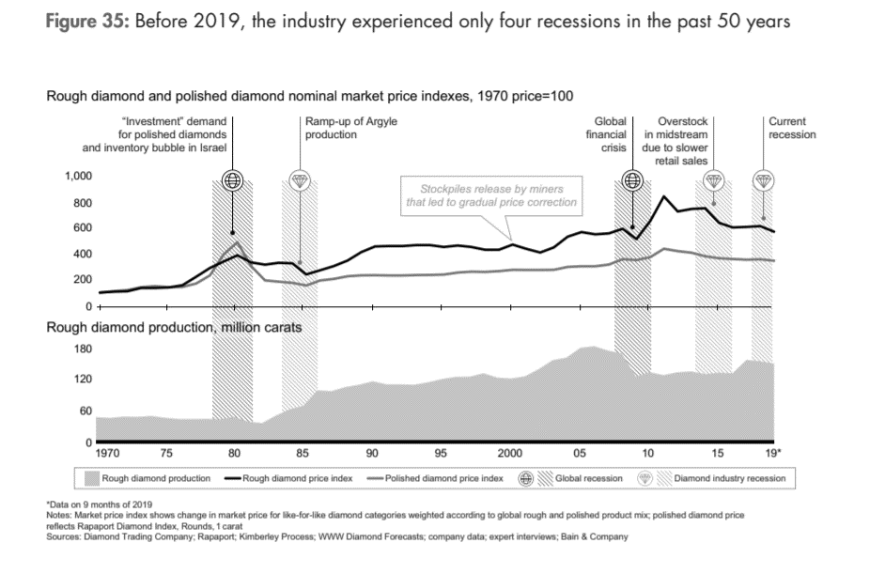
Source: Bain & Company. The Global Diamond Industry 2019.
To exemplify, demand for diamonds has plummeted during the pandemic, freezing sales and squeezing prices. With temporary mine closures at risk of becoming permanent, diamond miners are seeking ways to extract more value from their stones. The lone bright spot has been steady demand for large, high-quality diamonds from affluent investors, according to financiers and sales data. “There are a lot more enquiries from people seeking to buy these luxury stones as a hedge,” said Chris Del Gatto, CEO of the DelGatto Diamond Finance Fund, the largest non-bank lender to the diamond, jewellery and watch industries. Prices for high quality one-carat diamonds are rising steadily and are currently around 12% higher than at the start of the year, in contrast to still-depressed prices for lower-quality stones of the same size (Reid, 2020).
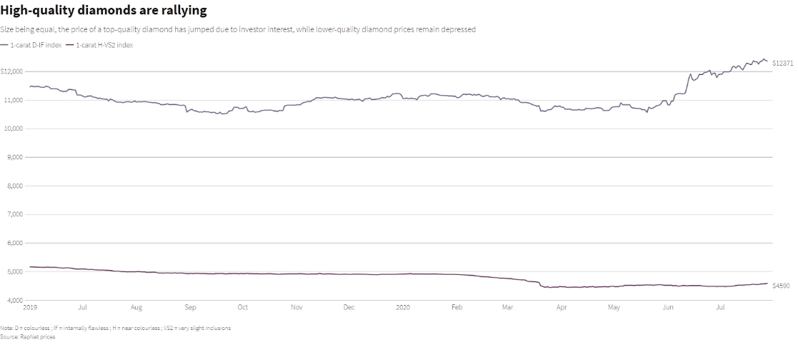
Source: Reid, H. From carats to peanuts: how a pandemic upended the global diamond industry.
COVID-19 restrictions has forced miners to cancel or delay sales. The few sales that have taken place showed rough diamond prices down between 15% and 27%. Indian imports of rough diamonds plunged from $1.5 billion in February to just $1 million in April. Antwerp, another diamond hub, saw rough imports drop 20% year-on-year in the first half. The city's exports of polished diamonds fell 46%. Overall, fine jewellery sales are expected to drop 19% this year, compared to a 3% rise last year (Reid, 2020).
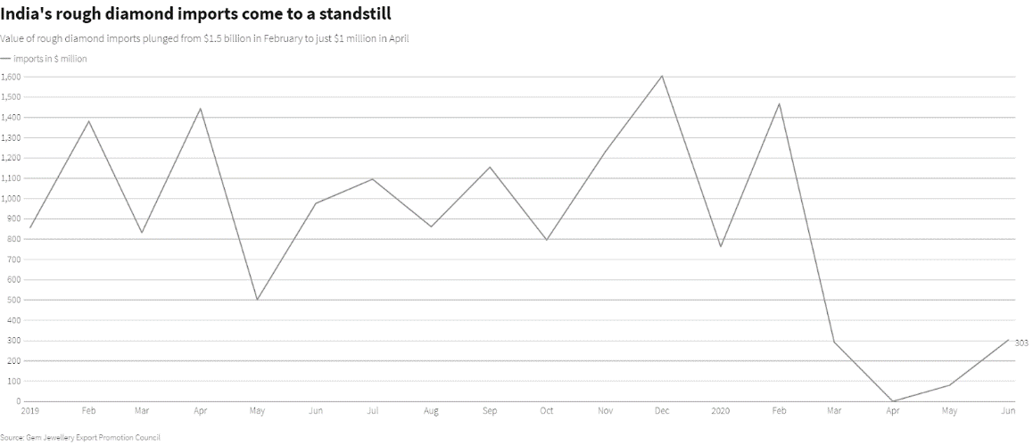
Source: Reid, H. From carats to peanuts: how a pandemic upended the global diamond industry.
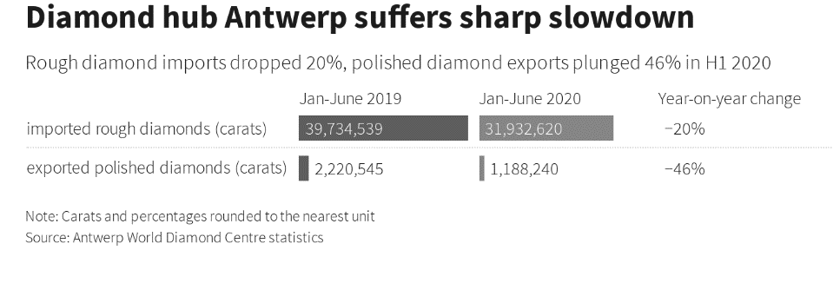
Source: Antwerp World Diamond Centre statistics.
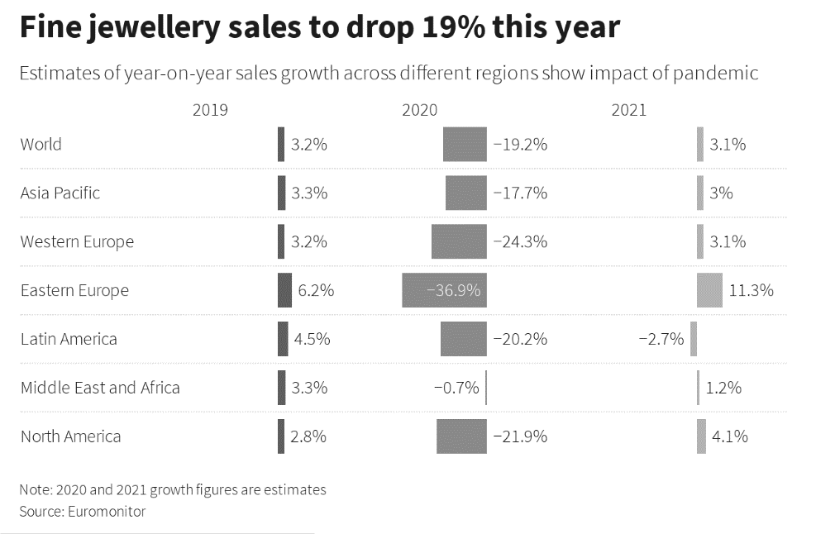
Source: Reid, H. From carats to peanuts: how a pandemic upended the global diamond industry.
Marketing strategy using the example of De Beers
A major challenge for the diamond industry is that diamonds are, by their nature, durable goods and not perishable. Steady production of a good that never perishes must eventually lead to oversupply, however low the enforced level of production. Constraining supply was therefore not sufficient to sustain a price for diamonds that maintained their status as a luxury good. Given that the jewelry market accounts for more than two-thirds of rough diamond sales, De Beers bypassed its distribution channels and tailored its marketing campaign to the end consumer. This effective “pull” through the distribution channel has been the result of a brilliant marketing strategy. Much of the success of De Beers has been created by this global campaign, one of the first—and most intensively pursued—ever implemented. Key objectives of the campaign have been to create an image of diamonds that positions diamonds at the peak of the Maslow hierarchy of needs—a luxury whose cost is nothing compared to its value and as a gift of love—the larger and finer the diamond, the greater the love;
Tactics included placing diamonds in early romantic Hollywood movies and eventually the “Diamonds Are Forever” campaign, which was targeted at growing the engagement ring market in the Far East but became a catchphrase for the entire industry. Not only did this theme play on the notion of eternal love, it also imbued diamonds with an eternal sentimental value, making it much less likely that diamond owners would resell their diamonds. The end result of this campaign is that women, who make up more than 90 percent of diamond owners, are trained to measure their partner’s devotion in terms of carats and brilliance (Chang, 2002).
Conflict diamonds and Kimberley Process Certification Scheme
Such definition as conflict diamonds emerged as a result of civil wars spilled across Africa in 1990s, more precisely in Angola, Sierra Leone, Rwanda, Liberia, DRC, and Cote d’Ivoire. These wars garnered worldwide attention and the international community decided to intervene in conflicts in order to put an end of the cruelty of rebel practices. The United Nations provided the following definition of conflict diamonds:
- “Conflict diamonds are diamonds that originate from areas controlled by forces or factions opposed to legitimate and internationally recognized governments and are used to fund military action in opposition to those governments, or in contravention of the decisions of the Security Council” (the United Nations, 2000).
The diamonds played the main role in financing the conflict due to their extremely high price, their efficient convertibility to money or arms, their small practical size, their indestructibility, and the difficulty with which their origin can be established (Olsson, 2007). These could be proved by several examples. For instance, during the Sierra Leone Civil War (1991-2000) the major rebel funding sources were diamonds. During the war the RUF rebel movement received 25-75 billion dollars per year from the trade in illegal diamonds. Another example is the Angolan Civil War, which took place from 1991 to 2002. It is estimated that UNITA rebel movement earned 200-600 billion dollars per year from the illegal diamond sales (Le Billon, 2008).
The United Nations implemented several measures in order to prevent the development of conflicts. In addition to authorizing peacekeeping missions, the UN implemented “smart sanctions” – sanctions on high-value commodities such as oil, diamonds, and timber, which financed the conflict. The UN Security Council applied sanctions against diamonds from Angola, where UNITA rebels were able to continue the fight because of their access to diamond revenues (Haufer, 2010). The UN Security Council adopted resolutions 1173 and 1176 that prohibited direct or indirect import of all Angolan diamonds that were not certified by the government. Sanction were, also, implemented against diamonds from Sierra Leone as the RUF refused to return diamond fields to the government. In 2000, the Security Council’s resolution 1306 imposed a ban on all import of diamonds supplied by the RUF (Olsson, 2007). Unfortunately, sanctions implemented by the UN didn’t achieve their goal and were not successful in reforming regimes or ending conflicts.
In 2000, the World Federation of Diamond Bourses and the International Diamond Manufacturers Association passed a resolution creating the World Diamond Council (WDC) to address the conflict diamonds issue. The mandate of the WDC was to develop a tracking system for the export and import of rough diamonds to prevent their illicit use. It was necessary to provide the system of warranties in order to assure buyers that the rough diamonds they purchased did not come from conflict zones. Members of the WDC and other sectors, including banks, insurers, and shippers committed not to do business with anyone dealing in conflict diamonds (Haufer,2010).
In 2001, the industry began to implement a voluntary system of certification, the main goal of which was to prevent the purchase and distribution of conflict diamonds. As such a system could not be implemented effectively by industry alone, the WDC called for the implementation by governments of export and import controls to back up and enforce the diamond certification system. Governments had to implement policies that would only permit trade in legitimate diamonds, and enforcement them through their customs systems (Haufer,2010).
The African states recognized the issue of conflict diamonds and in 2000, the South African government hosted in Kimberley the first UN-sponsored negotiations among industry representatives from the WDC, major diamond producing states, major consuming states, and civil society organisations. This meeting launched the negotiations to create Kimberley Process. By the end of 2000, the UN General Assembly adopted a resolution supporting the establishment of a diamond certification system, as proposed by the WDC as the part of the Kimberley negotiations. The Kimberley Process Certification Scheme entered into force in 2003 with over 40 member countries, the WDC, and the two NGOs that started it all – Global Witness and Partnership Africa Canada (Haufer,2010).
Key challenge: synthetic diamonds vs natural diamonds
The urgent issue of the diamond industry is the prognose of decline in rough mined diamond supply from 125 million carats in 2014 to only 14 million carats in 2050, whereas demand for rough diamonds will rise to 292 million carats. At the same time, technological developments in synthetic diamonds growing allow to create diamonds which are identical to the mined diamonds. Both grown and mined diamonds are real diamonds and they have the same physical, chemical and optical properties. There is no difference between grown and mined diamonds except for where they are grown. In addition, both diamonds are certified, forever and composed of pure carbon (Sanyal, 2015). It creates a condition for mined diamond’s companies being under the threat. Let’s consider more precisely what could be the main reasons.
Firstly, the demand for diamonds prognoses to rise in the future while supply of mined diamonds is unlikely to rise at a sufficient rate to keep pace with the growth of demand. It is considered that the excess demand will result in a higher rate of penetration of synthetics into the market which may well result in a decrease in prices at the gem quality diamond market. Assuming that these long-term projections of excess demand are in fact correct, the shortage of mined diamonds will create a space for synthetics and the industry of synthetic diamonds will have a chance to increase significantly (Grynberg, 2014).
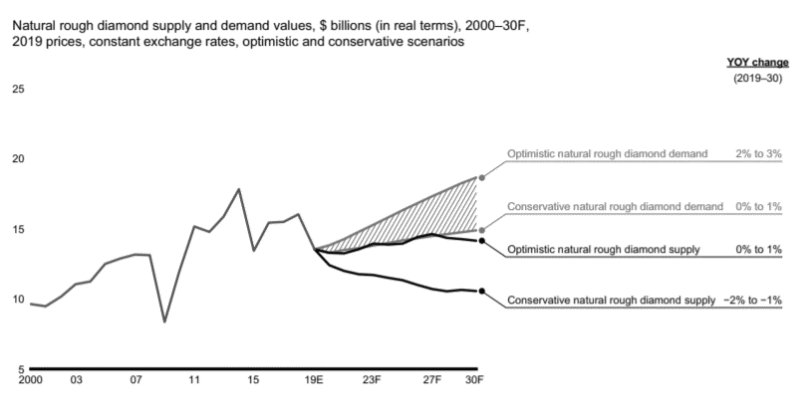
Source: Bain & Company. The Global Diamond Industry 2019.
Secondly, the projected growth in demand could be explained by the growth of income and demand for gem quality products in the emerging Asian and Middle Eastern markets. At the same time, some researches suppose that the reason for such demand is successful marketing that have shifted demand to diamonds as a result of the following of western marriage rituals rather than those using traditional items such as gold or jade (Grynberg, 2014).
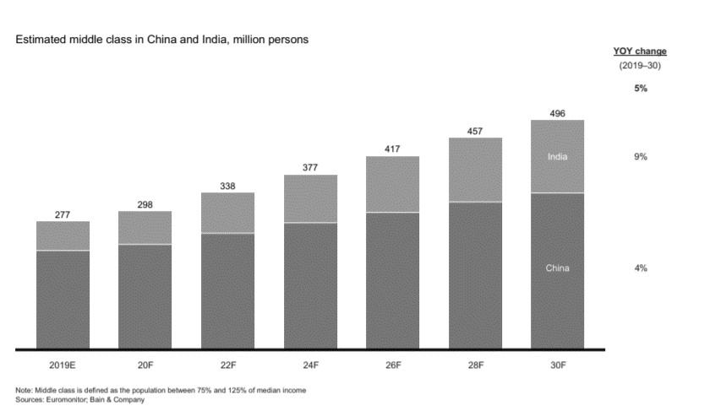
Source: Bain & Company. The Global Diamond Industry 2019.
Thirdly, the increased competitiveness in the number of diamond producers creates an uncertainty regarding future prices of diamonds. The entry of many small synthetic diamond producers in China, which will, once they are more technologically proficient in the production of high-quality synthetic gems, be able to produce gem quality diamonds at relatively low cost (Grynberg, 2014).
Finally, the high-profile images of on-going human rights abuses associated with diamond mining, child labor in the Indian cutting industry, and most importantly the use of diamonds to fund conflicts in Africa, has adversely impacted the image of the mined diamonds as a symbol of eternal love. In those parts of the world where such human rights and environmental considerations matter to buyers, these has undermined the reputation of mined diamonds (Grynberg, 2014). Many of the marketing outlets that are involved in the sale and distribution of the synthetics emphasize the absence of conflict, human rights abuses, along with a much smaller carbon footprint, are seen as important positive features of the marketing of synthetics
References
- ALROSA. 2020. URL: http://eng.alrosa.ru/operations/sales-policy/ (Accessed 2020-12-20).
- ALROSA’s Investor Presentation. 2019. URL: http://www.alrosa.ru/wp-content/uploads/2019/06/ALRS-Investor-Presentation-Sberbank-4-5-June.pdf (Accessed 2020-12-17).
- Bain & Company. The Global Diamond Industry 2019. 2019. URL: https://www.bain.com/contentassets/e225bceffd7a48b5b450837adbbfee88/bain_report_global_diamond_report_2019.pdf (Accessed 2020-12-19).
- Bain & Company. The Global Diamond Report 2013: Journey through the Value Chain. URL: https://www.bain.com/insights/global-diamond-report-2013/ (Accessed 2020-12-17).
- Chang, S.-Y., Heron, A., Rocca, L., Kwon, J., Maxwell, G., Tarajano, O. The Global Diamond Industry. Chazen Web Journal of International Business. 2002. Doi:10.1057/9781137537614.
- De Beers Group Auctions. 2020. URL: https://www.debeersgroup.com/about-us/our-operations/sales (Accessed 2020-12-17).
- De Beers Group. Global Sightholders Sales. 2020. URL: https://gss.debeersgroup.com/about-us (Accessed 2020-12-17).
- Grynberg, R., Sengwaketse, M., Motswapong, M. Synthetic Gem Quality Diamonds and their Potential Impact on the Botswana Economy /R. Grynberg, Sengwaketse M., M. Motswapong // BIDPA Publications Series. 2014. Pp. 1-26.
- Grynberg, R., Sengwaketse, M., Motswapong, M. Synthetic Gem Quality Diamonds and their Potential Impact on the Botswana Economy /R. Grynberg, Sengwaketse M., M. Motswapong // BIDPA Publications Series. 2014. P. 1-29
- Haufler, V. The Kimberley Process Certification Scheme: An Innovation in Global Governance and Conflict Prevention / V. Haufler // Journal of Business Ethics. 2010. №89. P. 403-416.
- Jotanovic, V., D’Ecclesia, R.L. Do Diamond Stocks Shine Brighter than Diamonds? Journal of Risk and Financial Management. Vol. 12, Issue 2, 2019: 1-19. Doi: 10.3390/jrfm12020079.
- Kumar, S., Kumar, D. , Sengupta, K., Giri T.K. Impact of community-based business model and competitive advantage on exports: evidence from diamond industry. Competitiveness Review, Vol. ahead-of-print, 2020. Doi: 10.1108/CR-12-2019-0130.
- Le Billon, P. Diamond Wars? Conflict Diamonds and Geographies of Resource Wars / P. Le Billon // Annals of the Association of American Geographers. 2008. Pp.345-372.
- Munier, Nathan. Diamonds, dependence and De Beers: monopoly capitalism and compliance with the Kimberley Process in Namibia. Review of African Political Economy. 43:150, 2016: 542-555. Doi: 10.1080/03056244.2015.1085380.
- Olsson, O. Conflict Diamonds / O. Olsson // Journal of Development Economics. 2007. №82. Pp. 267-286.
- Reid, H., Heiberg, T., Jadhav, R. From carats to peanuts: how a pandemic upended the global diamond industry. Reuters. 2020-08-12.
- Sanyal, S.S., Sharma, S.P. Grown Diamonds, A Sunrise Industry in India: Prospects for Economic Growth / S.S. Sanyal, S.P. Sharma // PHD Chamber of Commerce and Industry. 2015. Pp. 1-31.
- The auction house of the Russian Federation. The world diamond market. 2020. URL: https://www.auction-house.ru/en/news_analytics/rynok-almazov-mira/ (Accessed 2020-12-17).
- The Observatory of Economic Complexity. Diamonds. 2020. URL: https://oec.world/en/profile/hs92/diamonds?redirect=true (Accessed 2020-12-17).
- The United Nations. Press Release GA/9839. URL: https://www.un.org/press/en/2000/20001201.ga9839.doc.html#:~:text=html)%20%22conflict%20diamonds%20are%20diamonds,in%20opposition%20to%20those%20governments%22. (Accessed 2020-12-17).

