Report on the topic: “International Trade in Wheat”
Prepared by Bondarchuk D., Kalina S.

Wheat is one of the most important food crops, it is produced in 120 countries and accounts for about 19 percent of the world’s calorie supplies. The global wheat situation and wheat policies of major actors are central to the food security and dietary preferences of many countries.
It is cultivated on more land areas than any other commercial crop in the world. The global wheat generation is positioned third, in terms of volume, after corn and rice. Unlike some other commodities that are dominated by single producers, no one country dominates the wheat market. Wheat is adapted to a broad range of moisture conditions from dry weather to seaside moisture [3].
Wheat was first cultivated in southeastern Turkey in 9600 BC. By 6500 BC, the cultivation of emmer (a type of wheat) reached Greece, Cyprus and the Indian subcontinent, Egypt shortly after 6000 BC. and Germany and Spain by 5000 BC. By 4000 BC. wheat reached the British Isles and Scandinavia. After about two millennia, wheat reached China. From Asia, wheat continued to spread throughout Europe. In the era of Roman conquest, wheat began to be grown in different parts of Europe. In the 16-17 centuries, European colonists brought wheat to South America, and then to North America, at the turn of the 18-19 centuries – to Canada and Australia [4, p. 24]. Therefore, wheat became ubiquitous.
Wheat is a major food staple because of the wheat plant’s agronomic adaptability, ease of grain storage, and ease of converting grain into flour for making staple food products. Wheat is the major source of carbohydrates in the diet of people from many countries, including Australia, most of Europe, Northern Asia, and Northern Africa [13].
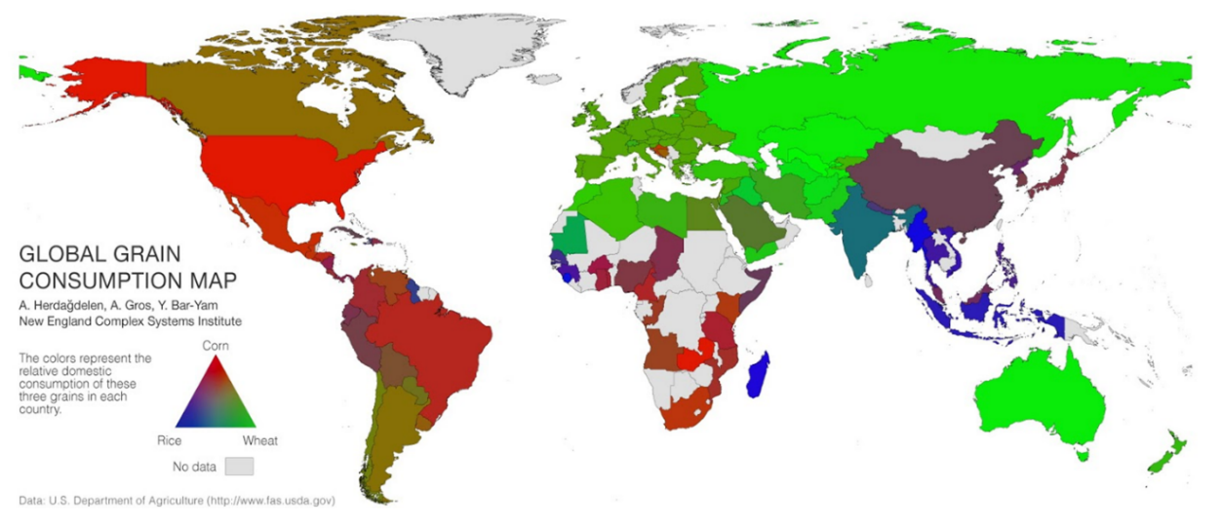
Figure 1 Global grain consumption map
Source: US Department of agriculture, available at: https://www.fas.usda.gov/ (accessed 7 December 2020)
There are many characteristics of wheat. Wheat can be classified into several main types. Classification by nutritional characteristics: soft wheat and durum. Soft wheat has a lower gluten content and is used to make plain and self-rising flour, making it ideal for making cakes, biscuits and baked goods. Durum wheat has a high protein content and, if it also contains good quality gluten, can form a firm and elastic dough, making it the best wheat for bread flour.
Classification by cultivation method: spring wheat and winter wheat. Spring wheats, planted in the early spring, grow quickly and are normally harvested in late summer or early autumn. Winter wheat is a wheat that is sown in autumn and ripens the following spring or summer [15].
To start with, there is a great number of wheat associations, especially in the USA and Canada, and one of them that worth being mentioned is The National Association of Wheat Growers (NAWG) is an advocacy group based in Washington, D.C. that supports the collective interests of wheat farmers in the United States. It was founded in 1950, and is structured as a federation of state grain growers’ associations. It is affiliated with Wheat PAC, a political action committee, and National Wheat Foundation, a charitable organization [12].
The Cairns Group is a coalition of 19 agricultural exporting countries (members) which account for more than 25 per cent of the world’s agricultural exports, and one observer (Ukraine). It is necessary to note that this group does not include Russia. Since the Group's establishment in Cairns, Australia, on 25-27 August 1986, its members have continued to push for liberalization of global trade in agricultural exports. The Cairns Group's ambition and broad objectives for the agriculture negotiations were set out in its “Vision Statement”. The Vision Statement outlines the Cairns Group's objectives in each of the three key reform areas within the framework for agricultural trade. These include deep cuts to all tariffs (including tariff peaks) and removal of tariff escalation, the elimination of all trade-distorting domestic subsidies; the elimination of export subsidies and clear rules to prevent circumvention of export subsidy commitments [8].
Apart from organizations which devote their work to mainly the wheat market, there is a couple to mention which pays attention to grain trade in general including wheat as well. The International Grain Trade Coalition Association (IGTC) is an international not-for-profit association, established in Switzerland, formed in 2001. The IGTC provides for commercially driven and consensus-based advocacy on behalf of its members and corporate stakeholders. Their mission is to provide advice on the impacts of policy decisions on commercial requirements and economics of the world's food, feed and processing industries [10].
Another organization includes Russia as a member. The International Grains Council (IGC) is an intergovernmental organization, its objections are: further international cooperation in grains trade; promotion of expansion, openness and fairness in the grains sector; contribution to grain market stability and enhancing world food security. Its membership consists of all the parties to the Grains Trade convention in 1995 [11].
Another question needs to be taken into account is wheat prices and factors which have an influence on them. That is why it is necessary to consider 10 main drivers of wheat price explained below:
1) Energy costs. Higher energy costs imply higher costs of production for wheat and higher costs of transporting wheat to market. Energy makes up a significant part of operating costs for most crops. This is especially true when considering indirect energy expenditure on fertilizer because the production of fertilizer is extremely energy intensive, requiring large amounts of natural gas. For some crops – including wheat – the combined cost of energy and fertilizer make up a significant part of the total operating expenses.
2) Income growth. Rising incomes drive greater wheat consumption, particularly in developing countries where caloric intake is more responsive to income growth. Moreover, consumers in developing countries adjust their diets in response to newfound wealth, eating proportionately more meat and less grain. This change in diet diverts grain to animal feed use. Around 15%-20% of wheat production is used for animal feed.
3) Weather. The weather has a significant impact on crop yields and thus overall agricultural production. The wrong type of weather at the wrong time in the planting cycle, even if not prolonged or extreme, can also adversely affect the production of certain crops.
4) Substitution effect. Because wheat and other grains are close substitutes an increase in the price of corn for example could lead to a corresponding rise in the price of wheat. If the price of corn rises too far then farmers begin to switch from wheat to corn, reducing the supply growth of wheat. Meanwhile consumers might switch in the opposite direction increasing their demand for the relatively cheaper wheat grain.
5) The US Dollar. Like most internationally traded commodities wheat is priced in US dollars. At its most basic a decrease in the value of the US dollar relative to a commodity buyer’s currency means that the purchaser will need to spend less of their own currency to buy a given amount of the commodity. As the commodity becomes less expensive demand for the commodity rises, resulting in an increase in the price and vice versa. A weaker dollar can also act as a disincentive to producers to increase output. Wheat prices have a relatively high inverse correlation against the dollar of around -0.55.
6) Stock levels. Stocks, otherwise known as inventories, act as form of buffer for both producers and consumers of wheat. Typically, falling stock levels occur if demand increases faster than supply, resulting in higher wheat prices. Falling stock levels may, however, make the wheat market more vulnerable to an unanticipated disruption to supply or a sudden increase in demand.
7) Government intervention. Given wheat’s position as one of the most important sources of food, the governments of economies – both developed and developing – may look to restrict the supply of wheat with the aim of supporting domestic farmers or consumers or both. Governments may also restrict exports of certain essential foodstuffs, often when the fear of domestic shortages and/or high prices is greatest. In 2010 Russia and Ukraine imposed wheat export restrictions in order to maintain domestic prices at a lower level and ensure availability. However, such action typically just makes the situation worse. By reducing the amount of wheat available to the global market prices are likely to increase further.
8) Expectations. If wheat farmers expect a high price then they will plant more wheat relative to other crops in the following year. When the farmers then go to market with the second year’s harvested crop, supply will be high, resulting in a drop in the price of wheat. If farmers then expect low prices to continue, they will reduce the planting of wheat for the subsequent year, resulting in a return to high wheat prices yet again
9) Speculation. During the spike in food prices around 2010-12 attention centered on the role of speculators, arguing that unprecedented buying pressure from new financial index investors had created a massive bubble in the price of wheat and other agricultural commodities. Although there is limited evidence to support that theory speculators do play an important role in the wheat market, by signaling to the market future shortages or gluts and taking on risk from farmers looking to hedge future wheat production.
10) Transportation. High cost and unreliable transport and/or poor logistics can affect the supply of wheat, even if the harvest has been good. Given that wheat is exported from a number of large producers (Russia, Ukraine and Australia to name a few of the largest) delays in getting wheat to storage and then poor handling can result in the crop spoiling, reducing the potential crop that can reach the market [6].
Another issue to consider is the situation with wheat exports. In the figure 2 is depicted the dynamics of wheat exports from 1995 to 2018. Initially, the leaders of export in wheat were North American countries. For example, in 1996 gross export in North America counted for more than 10$ billion, while in Europe gross export in wheat counted for only 6$ billion and in Oceania – for 5$ billion. Then nearly after 2006 there were changes in the leading position, the competition was mainly held between Europe and North America. Eventually, starting from 2009 Europe became the main leader, having a gross export value of 23.1$ billion. 11.1$ billion is a gross export value of North America, 2.23$ billion – of South America, 2.8$ billion – of Oceania and 1.45$B – of Asia [7].
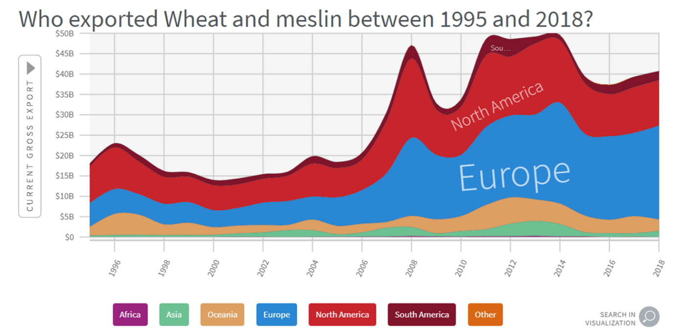
Figure 2 Dynamics of world wheat exports from 1995 to 2018.
Source: The Atlas of Economic Complexity, available at: https://atlas.cid.harvard.edu/explore/stack?country=undefined&year=2018&startYear=1995&productClass=HS&product=736&target=Product&partner=undefined (accessed 5 December 2020)

On the map in figure 3 depicted the main wheat exporters and the share in world exports in 2018. The main exporters are Russia, USA, Canada, France and Australia. Detailed description will be presented further in the analysis of exports in 2019. It is also necessary to note, that one of the biggest exporters – Ukraine, did not provide trade data of its exports in wheat in 2019 and therefore will not be taken into account in further analysis of export in 2019. The global wheat production was valued at a volume of 732 million metric tons in 2018, and it is expected to witness a CAGR of 1.3% during the forecast period [14].
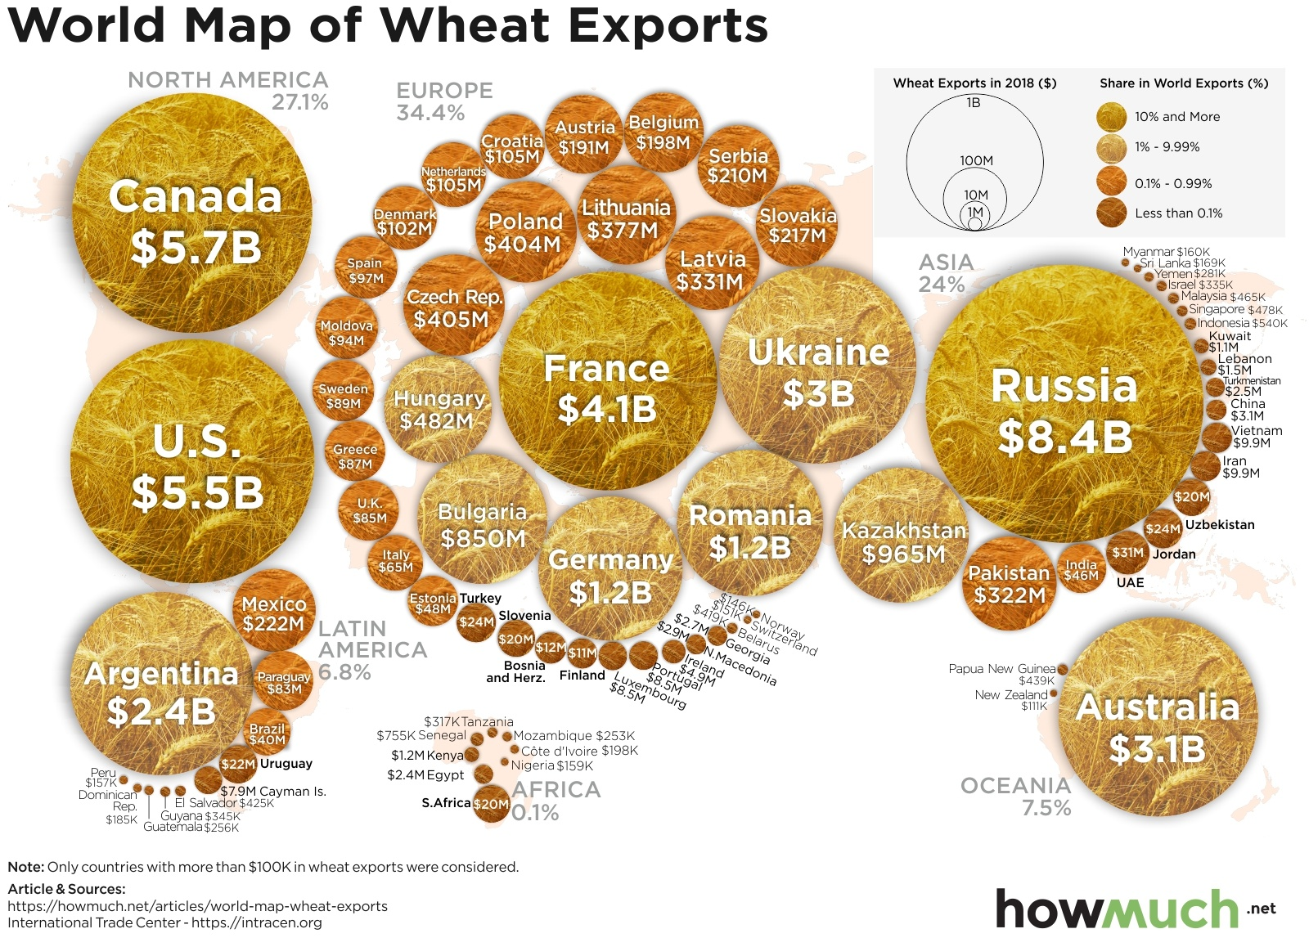
Figure 3 World map in wheat exports in 2018
Source: howmuch.net, available at: https://howmuch.net/articles/world-map-wheat-exports (accessed 6 December 2020)

When it comes to the top five wheat exporters, in 2019 it is possible to highlight Russia, which has an export value of more than 6.4$ billion and holds the first place. The second one is the United States with an exporting value of more than 6.2$ billion, leaving behind Canada, which has an export value of more than 5.3$ billion and France with more than 4.3$ billion. The fifth place goes to Australia, an export value of which counts for more than 2.4$ billion [16].
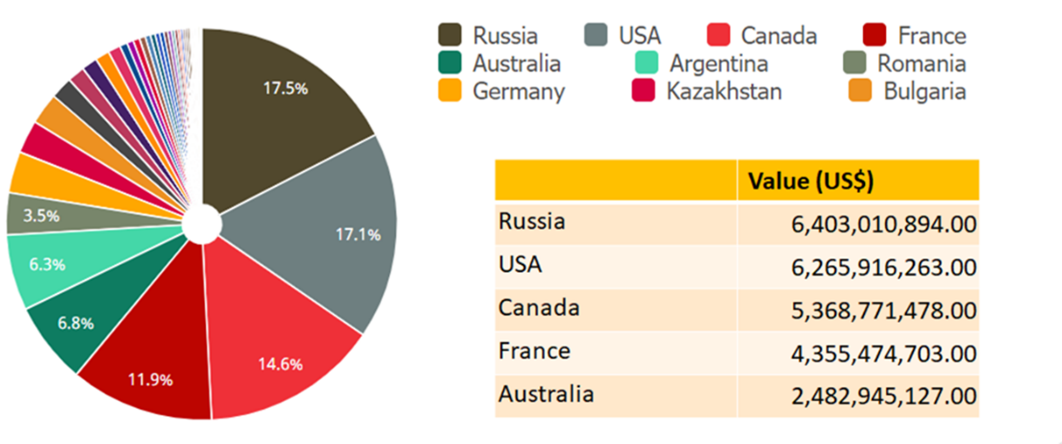
Figure 4 Top 5 exporters of wheat in 2019
Source: TrendEconomy, available at: https://trendeconomy.com/ (accessed 6 December 2020)

It is also necessary to realize how important this sector is for national export. For all five main wheat exporters the situation appears to be almost the same: the share of wheat export in national export is not so big and counts for about 1%. Among all of them, the biggest share belongs to Russia – 1.5%, the smallest one belongs to the US – only 0.38%. As for the rest of the leading exporters, Canada’s share of wheat export in national export share counts for 1.2%, Australia’s – 0.93% and for France it is 0.78% [16].
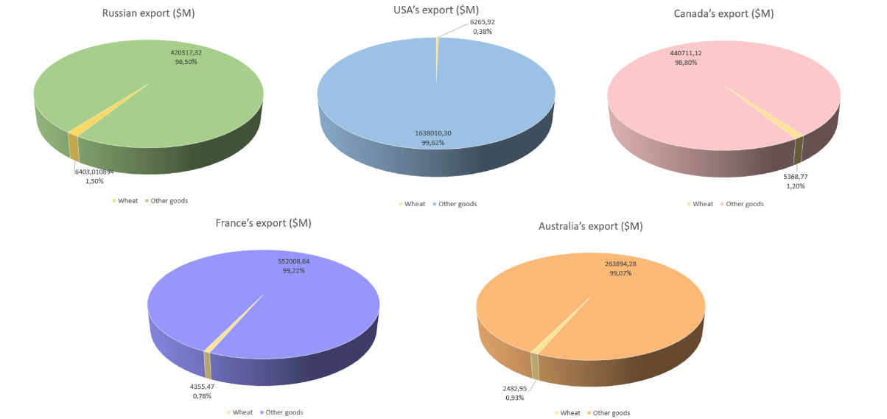
Figure 5 Wheat export share in national exports in 2019
Created by authors, data: TrendEconomy, available at: https://trendeconomy.com/ (accessed 6 December 2020)

In addition, it is also important to know how wheat export changed during the last 5 years for 10 leading exporters of this type of good. The value of wheat export average growth in 2014-2019 has been taken into account. As presented in figure 6, most of these countries experienced decrease in export value: the biggest one was in Germany – almost -16.5%, then goes Australia with -14.2%. Not so significant decrease is depicted for the USA, Canada and France – from -4% to -6% on average. As for Romania, its decrease in national share can be assumed as not so significant. When it comes to the increase, the largest one happened with Argentina – +30.62%, in 2019 this country was on the 6th place in the list of wheat exporters. Another country, which has a positive tendency in wheat export growth is Bulgaria – almost +7%. Russia has a growth rate of more than +3% and keeps quite positive dynamics [16].
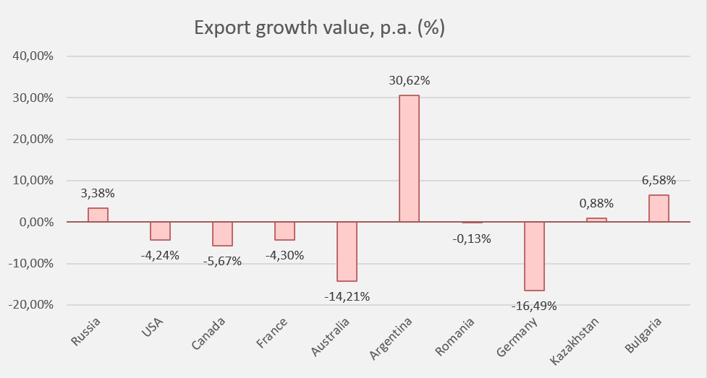
Figure 6 Wheat export growth in value in 2015-2019
Created by authors, data: TrendEconomy, available at: https://trendeconomy.com/ (accessed 7 December 2020)

Then it is essential to analyze the aspects of import in wheat. Following the same algorithm, it is possible to consider the dynamics of wheat import in 1995-2018. Figure 7 depicts a sharp increase in the value of wheat import in the world in general terms. During the whole period the leadership belonged to Asian countries with exceptions in several years, when import of European countries prevailed. However, in the beginning of the observed period it is more difficult to identify a clear leader. In 2018 the leading importing countries are located in Asia and have gross import value of more than 15$ billion, leaving behind African countries with gross import value of 11% billion. Less active importers of wheat are located in Europe with gross import value of 8.4$ billion and then goes North America and South America, having gross import value of more than 2.5$ billion [7].
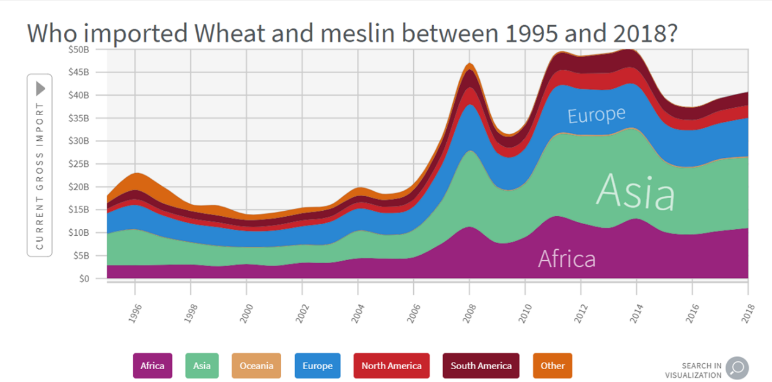
Figure 7 Dynamics of world wheat imports from 1995 to 2018.
Source: The Atlas of Economic Complexity, available at: https://atlas.cid.harvard.edu/explore/stack?country=undefined&year=2018&startYear=1995&productClass=HS&tradeDirection=import&product=736&target=Product&partner=undefined (accessed 5 December 2020)

Considering top 5 wheat importers, wheat import is distributed almost equally among all countries, that is why it is difficult to highlight the only leader. The first place belongs to Egypt, which has an import value of more than 3$ billion. Then goes Indonesia with an importing value of more than 2.7$ billion, leaving Turkey behind, which has an import value of more than 2.3$ billion. The fourth place is divided between two countries – Italy and Philippines, the import value of each counts for more than 1.8$ billion [16].
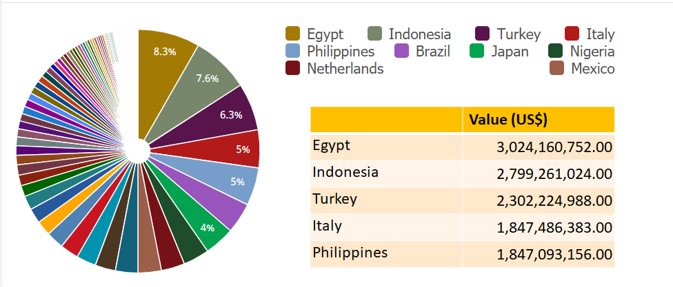
Figure 8 Top 5 importers of wheat in 2019
Source: TrendEconomy, available at: https://trendeconomy.com/ (accessed 7 December 2020)

In contrast with wheat export share in national export, wheat import share in national import seems to be bigger for some countries. For example, Egypt’s import in wheat counts for 3.8% of total import, which seems to be quite significant. Indonesia and Philippines have slightly smaller but also rather significant values of wheat import share – 1.64% and 1.58%. Turkey’s wheat import share in national import counts for more than 1% and the lowest share belongs to Italy – only 0.39% [16].
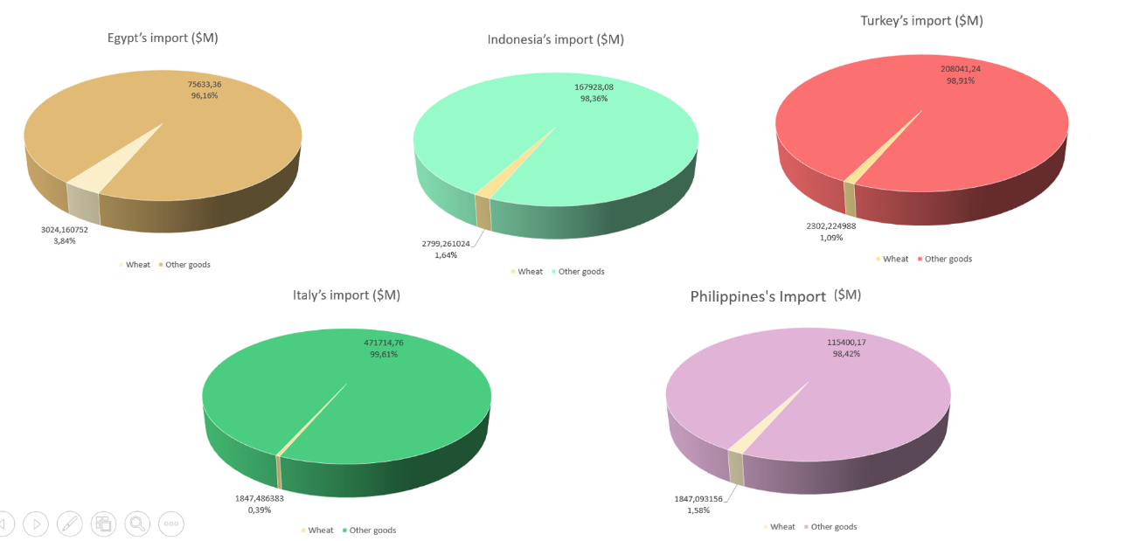
Figure 9 Wheat import share in national imports in 2019
Created by authors, data: TrendEconomy, available at: https://trendeconomy.com/ (accessed 6 December 2020)

When it comes to the average growth rate of wheat import for 10 leading countries in 2014-2019, the situation seems similar to wheat exporters. 6 countries out of 10 experienced a decrease in wheat import during 5 years. With an exception to Egypt, which experienced not such a significant decrease, the difference between decrease rates for the rest 5 countries (Italy, Brazil, Japan, Nigeria, and Mexico) seems to be not so big: from 3 to 6%. The biggest change happened to the Philippines, which experienced an increase in wheat import of almost 15%. The second country, to which happened a significant increase in wheat import is Turkey – 8% [16].
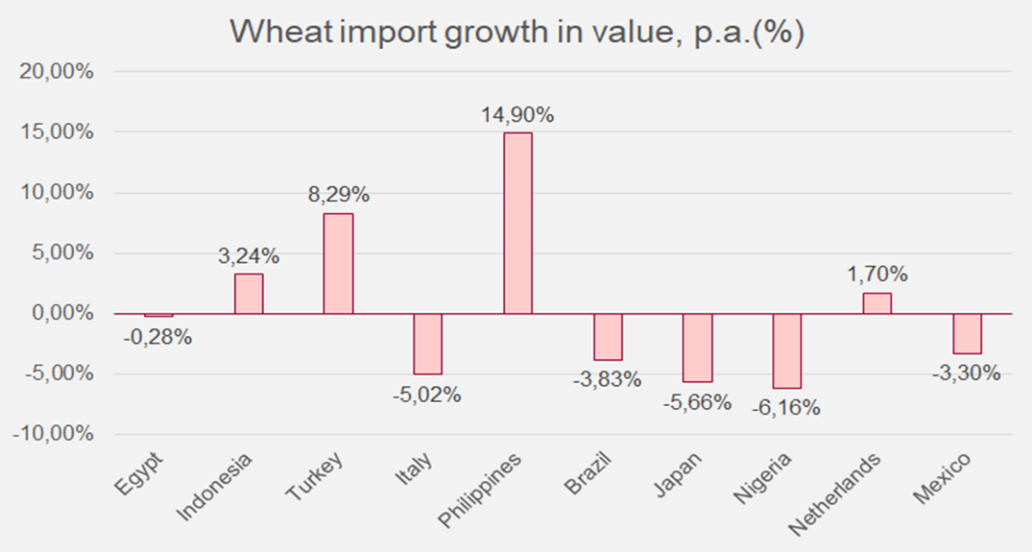
Figure 10 Wheat import growth in value in 2015-2019
Created by authors, data: TrendEconomy, available at: https://trendeconomy.com/ (accessed 7 December 2020)
Wheat is often shipped over long distances. It starts out on a farm, where wheat is harvested and stored locally, or transported by a truck to a storage elevator. From the storage elevator the wheat is gravity fed into a railcar and shipped to port where it is offloaded and then reloaded to another storage elevator, usually by conveyor belts. Here, the grain is accumulated until there is sufficient load for a merchant ship. At the other end of the voyage the process is reversed and the grain is offloaded from the ship into a storage elevator, and then shipped to a flour mill or feed compounder for further storage [5, p.423].
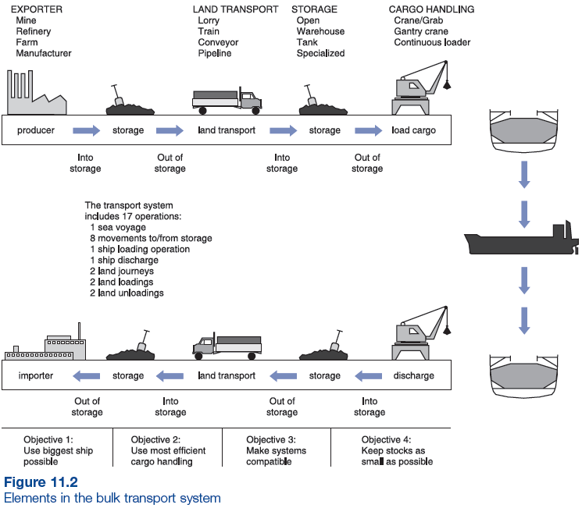
Figure 11 Elements in the bulk transport system
Source: M. Stopford, Maritime Economic, 3rd edition. Routledge, New York; 2009, p. 423

A commodity exchange is an exchange or market in which various commodities are traded. Most of the world's commodity markets trade in agricultural products and other raw materials. Including wheat. Figure 12 shows the cost of wheat on the commodity exchange for the last 5 years [9].
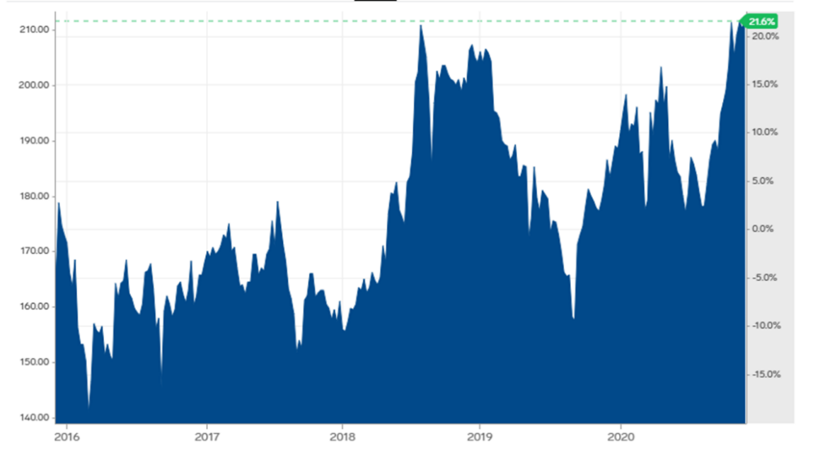
Figure 12 The cost of wheat on the commodity exchange for the last 5 years
Source: Market insider, available at: https://markets.businessinsider.com/commodities/wheat-price (accessed 7 December 2020)

Wheat trade is vulnerable to extreme climatic events, as well as to geopolitical developments, potentially contributing to disruptions or bottlenecks for the movement of commodities, both to established and developing markets, increased tensions between market actors. Governments often take actions that result in supply/demand imbalances in the wheat market, for example, import duties on wheat in an attempt to support domestic production. These taxes could lead to depressed demand for exports and lower global prices. Another the challenge is reduction of land suitable for sowing grain crops associated with a high level of urbanization and conservation of woodlands. Key challenges in the wheat market also imply environmental problems, including in connection with the introduction of previously unused lands into circulation. Limited amount of water resources is another important issue to take into account as well as the reduction in financing of agricultural production [1, p.3].
If one asks a question, which commodity is the most political, the answer is highly likely to be oil, which is quite obvious and can be proved by a great number of facts and evidence. However, some researchers emphasize the political significance of wheat and this point of view also is worth being explained. Wheat has a far longer history as a political commodity than oil. As the primary ingredient in bread and other staple food products, populations worldwide depend on annual wheat supplies for nutrition.
Moreover, wheat is a matter of national security. For leaders to maintain power, the availability of food is a key requirement. The French Revolution began as protests over bread and food shortages. Rising food prices and supply deficits have fomented uprisings and led to leadership changes throughout history. The most recent example came during the Arab Spring in 2010 as bread riots in Tunisia and Egypt changed the political leadership across many Middle Eastern countries. In other words, the all-time high in wheat occurred in 2008 at $13.34 per bushel played a role in the Arab Spring as high prices caused by low supplies triggered sweeping political change in North Africa and the Middle East.
The demand side of wheat’s fundamental equation is a function of the addressable market, which is continually growing. Each quarter, the world adds twenty million more people. Each year, there are approximately eighty million more mouths to feed. In 2020, there were more wheat consumers than in 2019, and in 2021 there will be more than in 2020. The addressable market continues to expand for wheat and all agricultural commodities.
Thus, not only does the global wheat market face some challenges but it also appears to be a challenge for policy of a country [2].
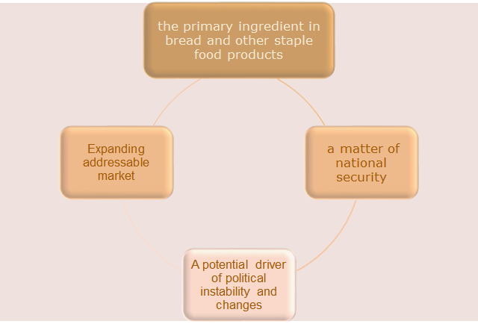
Figure 13 Wheat as a political commodity: main aspects
Created by authors, reference: A. Hecht, Why Wheat Is the Most Political Commodity, available at: https://www.investing.com/analysis/why-wheat-is-the-most-political-commodity-200544854 (accessed 7 December 2020)

The coronavirus pandemic has changed the world and the global economy. Many of the initial measures were expected negatively to affect the agricultural sector. But agriculture has in fact shown resilience, WTO said, with trade performance that has fared better than other sectors.
The initial response measures were aimed at addressing member countries’ most urgent concerns: containing the virus to save lives and ensuring domestic food security. In addition to lockdowns, these measures included policies that both facilitated and restricted agriculture trade – new sanitary and phytosanitary (SPS) measures and tariff reductions, as well as export restrictions. There also was an increase in stockpiling. Agricultural trade flows changed significantly, given a sudden change in consumption patterns triggered by the COVID-response measures put in place.
Initial measures focused on guaranteeing the immediate availability of food have been followed by a second phase of policies seeking to mend broken supply chains and help agricultural producers cope with the “new normal” situation. While many governments gradually have relaxed lockdown measures, removed several export restrictions and introduced domestic support measures to support the agricultural sector, WTO noted that the pandemic continues to spread in different parts of the world and is expected to continue to influence the demand for and supply of agricultural products [17].
In conclusion, wheat is one of the most important grain crops produced and traded globally. It is cultivated on more land area than any other commercial crop in the world. Wheat prices depend on such factors as energy costs, income growth, weather conditions, substitution effect, the US dollar, stock levels, government intervention, expectations, speculation and transportation. The main exporters are Russia, USA, Canada, France and Australia. The main importers are Egypt, Indonesia, Turkey, Italy, and Philippines. Wheat trade is likely to face such challenges as climatic events, geopolitical problems, reduction of land suitable for sowing grain crops, environmental problems, limited amount of water resources and reduction in financing of agricultural production. Apart from facing challenges, wheat trade can also create challenges to some countries’ policies. Wheat can be claimed as a political commodity, due to its significant role as a primary ingredient in bead and other staple food, a matter of national security, a potential driver of political instability and as an expanding addressable market. No matter that coronavirus pandemic has negatively affected the world economy, agricultural sector, including wheat market, has shown resilience owing to measures implied. However, this issue needs further investigations and it is too early to make any final conclusions before the end of the pandemic.

References
- A. Enghiad, D. Ufer, A. M. Countryman, and D. D. Thilmany, An Overview of Global Wheat Market Fundamentals in an Era of Climate Concerns // International Journal of Agronomy. Volume 2017, pp. 1-15.
- A. Hecht, Why Wheat Is the Most Political Commodity // Investing.com. – URL: https://www.investing.com/analysis/why-wheat-is-the-most-political-commodity-200544854 (accessed 7 December 2020)
- D.O. Mitchell and M. Mielke, Wheat: The Global Market, Policies, and Priorities. – URL: http://www.rrojasdatabank.info/glbagrtrade05/ch11.pdf (accessed 4 December 2020)
- Hogan CM, Saundry P, Editors. Wheat. Encyclopedia of Earth. National Council of Science and the Environment, Washington DC; 2013.
- M. Stopford, Maritime Economic, 3rd edition. Routledge, New York; 2009, 815 p.
- P. Sainsbury, Wheat prices: The top 10 most important drivers // Materials risks. – URL: https://materials-risk.com/wheat-prices-top-10-important-drivers/ (accessed 7 December 2020)
- The Atlas of Economic Complexity. – URL: https://atlas.cid.harvard.edu/ (accessed 5 December 2020)
- The Cairns Group. – URL: https://www.cairnsgroup.org/ (accessed 5 December 2020)
- The cost of wheat on the commodity exchange for the last 5 years // Market insider. – URL: https://markets.businessinsider.com/commodities/wheat-price (accessed 7 December 2020) (accessed 5 December 2020)
- The International Grain Trade Coalition Association. – URL: http://www.igtcglobal.org/ (accessed 5 December 2020)
- The International Grains Council. – URL: https://www.igc.int/en/default.aspx (accessed 5 December 2020)
- The National Association of Wheat Growers. – URL: https://www.wheatworld.org/ (accessed 5 December 2020)
- US Department of agriculture. – URL: https://www.fas.usda.gov/ (accessed 7 December 2020)
- Visualizing Wheat Exports by Country // howmuch.net. – URL: https://howmuch.net/articles/world-map-wheat-exports (accessed 6 December 2020)
- Wheat: Background // USDA. – URL: https://www.ers.usda.gov/topics/crops/wheat/wheat-sector-at-a-glance/ (accessed 4 December 2020)
- World Merchandise Exports and Imports by Commodity // TrendEconomy. – URL: trendeconomy.com (accessed 6 December 2020)
- WTO issues new report regarding impact of COVID-19 crisis on agricultural trade. – URL: https://www.wto.org/english/news_e/news20_e/agri_27aug20_e.htm (accessed 5 December 2020)

