

**REPORT ON THE TOPIC: "COFFEE MARKET: THE STRUCTURE, KEY PLAYERS, CHALLENGES"**

**PREPARED BY**

**SHUNYAEV DMITRIY   
DILDINA VALERIA**

**SAINT PETERSBURG STATE UNIVERSITY INTERNATIONAL TRADING SYSTEM 2020**

This report analyzes the coffee market. This paper contains the market structure, key players and vital challenges.

The global coffee market was valued at approximately $102.15 billion in 2019and it is expected to reach $155.64 billion in revenue by 2026. Coffee’s compound annual growth rate (CAGR) is expected to reach a record of 6.2% from 2020 to 2026. Coffee is one of the most consumed and popular beverages worldwide. With the rise of coffee shop culture in today's younger generation, as well as rising disposable income, white collar populations, urbanization and catering outlets are some of the factors contributing to the growth of the global coffee market. The shift in work culture, especially in the corporate industry, along with rising living standards, can be expected to further increase demand in the global market. Companies revising their service strategies as well as new modern brands to increase customer satisfaction and in turn gain loyalty are other factors improving the global coffee market across the globe.

Therefore, over the past ten years, coffee sales have doubled. At the end of 2019, this drink for the first time overtook the popularity of tea. Coffee is grown in 70 countries. All of them are located in the area of the so-called coffee belt zone on both sides of the equator (Figure 1). Annually 9.4 million tons of grains are produced. Coffee, like wine, is a mirror of the area in which it grows. Not only the soil, but also a unique combination of microclimate, weather conditions, altitude, and even processing methods affect the coffee taste. All these components play a huge role in shaping the unique characteristics of the drink. According to some clinical studies, modest coffee consumption is sparing or slightly beneficial for healthy adults. Coffee provides a revitalizing effect due to the presence of caffeine. Thus, demand for organic coffee is expected to grow further in the near future due to increased awareness of the health benefits of coffee consumption.

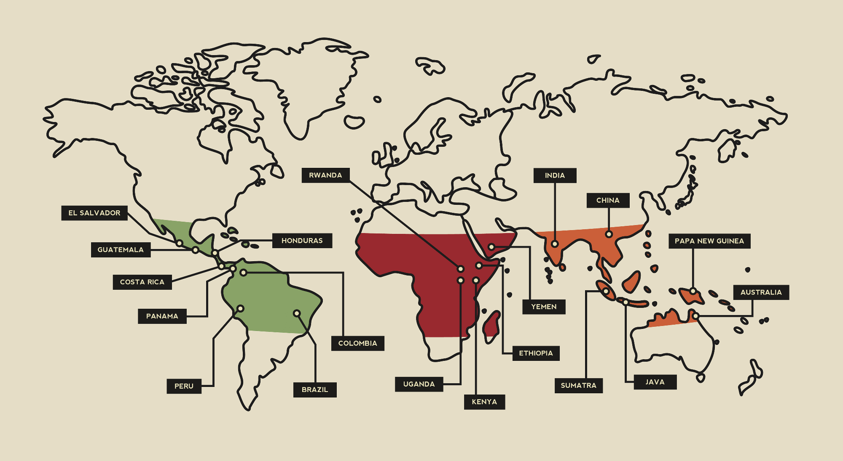

Figure 1 – Coffee belt.  
Source: https://bibium.com/bibium-infographics/bean-belt-infographic/

**Market trends**

The three major market trends are presented below. Figure 2 shows the first trend – a surge in demand for certified coffee products. From the past few years it has been noticed that consumers are getting more aware regarding the manufacturing of the product they are buying and from where their purchases are coming. This is applicable especially in the case of the supply chain of food and beverages, and coffee is not an exception. Therefore, consumers are readily looking for certified coffee products to be ensured about the credibility of their coffee purchases. Certified coffee is an assurance to the consumer about the reliability of the product, as coffee is becoming an increasingly common target for food counterfeiters. Universal Trade Zone (UTZ) Certification is the largest certification program in coffee and cocoa. UTZ aims to make sustainable farming a norm, by encouraging farmers to implement eco-friendly agricultural practices and manage their farms profitably with respect to coffee consumers and nature. A number of coffee certification organizations are engaged in keeping a check upon the production procedures and supply chain of coffee. Some of them are following: Fair Trade Certification, Rainforest Alliance Certification, UTZ Certification.

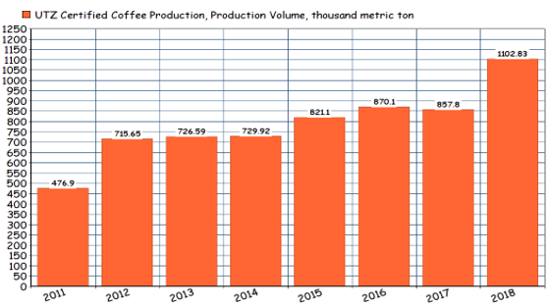

Figure 2 – Surge in demand for certified coffee products.

Source: https://utz.org/better-business-hub/sourcing-sustainable-products/utz-coffee-program-remains-stable-in-2019-with-increased-demand/

Second trend is that Europe holds a significant share in the market, it is shown on Figure 3. According to a survey conducted by the Institute for Scientific Information on Coffee (ISIC), 68% of the respondents stated that they often consumed coffee, while working. This trend is leading to a huge demand for coffee in the European countries, like Germany, Italy, Spain, the United Kingdom and others as consumers are becoming increasingly conscious about the quality of their coffee. Moreover, advancements in technology (like table-top machines and traceability tools) recreating the pathway for bean-to-cup solutions. The German coffee pods and capsules market is highly dominated by Nestle's Nespresso, with its wide product reach across the country. Keurig Green Mountain merged with JAB holding with an aim to expand its presence. This is expected to hinder the growth of nestle SA in Germany. As a report published by Nestle Nespresso SA, in Germany, the growing sense of coffee connoisseurship was most noticeable among younger generations. About 24.1% of 18-29-year-olds want to try different types of coffees, coffee recipes, and want diversity in the coffee industry.

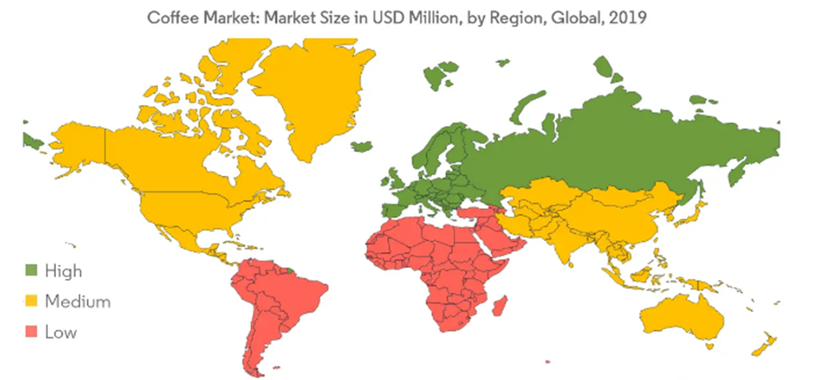

Figure 3 – Market share by region.

Source: https://www.mordorintelligence.com/

**Key players**

Regarding the key players, the most prominent ones in the market are Nestle, JM Smucker Company, The Kraft Heinz Company and Starbucks Coffee Company. The major strategies adopted by the companies in the market are new product development, agreements/partnerships, expansions, mergers, and acquisitions. The merger or acquisition of companies, in order to utilize the respective key strengths, such as intense R&D activities, distribution network, and the development of new products, to enhance the portfolio and capture the untapped markets, are also driving the coffee market. Due to the high growth potential of developing regions, most companies are trying to establish themselves in these regions by expanding their production lines, to serve the increasing need for coffee, globally. For instance, in 2018, Nestlé inaugurated a new Nescafé Dolce Gusto production in Vietnam. The site is expected to process approximately 2,500 metric ton of coffee per year (equivalent to 130 million capsules), using high-quality coffee beans from Vietnam.

**Coffee producers and brands**

Further, Figure 4 shows the top five coffee producers by country. The main supplier is Brazil. It accounts for about 40% of global flows. There are about 4 million fruit-bearing trees in this country, and up to 57% of the country's total crop can be harvested on 51 hectares.

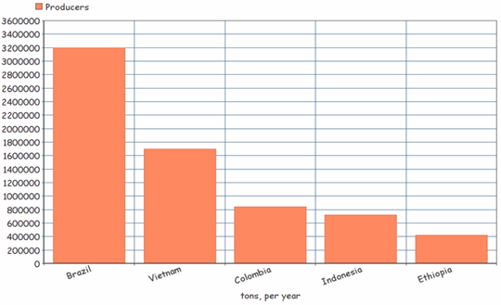

Figure 4 – Top - 5 coffee producing countries.

Source: https://www.mordorintelligence.com/

Further presents the world’s most popular coffee producers and brands. Figure 5 shows the top five popular coffee producers in the world and their packages.

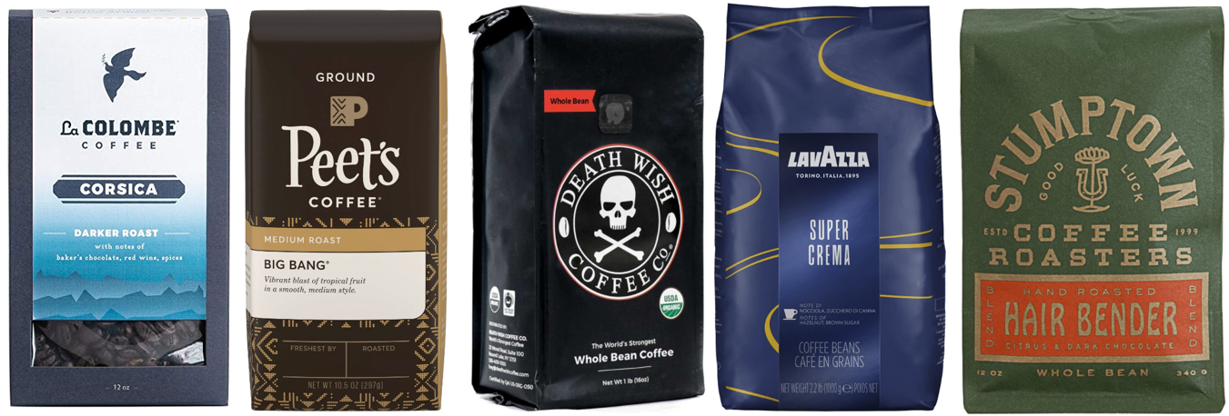

Figure 5 – Top - 5 coffee producers.

Source: https://myhealthgazette.com/the-best-coffee-brands-in-2020

Coffee prices approximately are 1000 ₽, 800 ₽, 1200 ₽, 600 ₽ and 1150 ₽ from left to right, if you look at the picture. All prices are per pack of 340 grams and were sourced from the Amazon site, since some brands are not represented on the Russian market, and the prices may be slightly higher than mentioned. The following provides more information about each of the brands.

La Colombe Corsica Blend a coffee shop started in Philadelphia has now become a wildly popular coffee brand nationwide. This blend is made from a mix of beans ethically sourced from Brazil, Colombia, Honduras, and Mexico, and is named after the ancient Mediterranean island. The Corsica blend has deep, dark, chocolatey notes and a robust flavor. Many reviewers specifically note that this is their "go-to morning blend" since it's both strong and versatile. The cocoa notes in this blend make it pair especially nicely with milk or cream, although it can certainly stand alone and be sipped black. With consistently positive reviews, a bold yet balanced flavor, and a smooth chocolatey finish that will leave you wanting another sip, La Colombe’s Corsica blend gets our vote for best everyday coffee.

Peet’s Coffee Big Bang Medium Roast this brand of coffee was established in Berkeley, California in 1966 at Alfred Peet’s coffee shop. This blend is crafted from fair-trade, USDA-Certified Organic Latin American and East African beans and gets a bright, fruity lift from Ethiopian Super Natural coffee beans that are added to the mix. Many reviewers call out lush, sweet, citrusy notes in this blend’s flavor and aroma.

Death Wish Coffee — an upstate New York-based brand that claims to make the world’s strongest coffee — makes one mean, dark-roast whole-bean coffee (their signature blend). Made with a blend of ethically sourced beans, Death Wish Coffee is both fair-trade and USDA-Certified Organic. Described as a “high-octane” coffee with a high caffeine concentration, the brand swears this coffee will "bring you back from the nights you thought you’d never wake up from". This dark roast is not only incredibly strong and highly caffeinated, but also well balanced and flavorful, with sweet nutty, chocolate notes and surprisingly smooth finish.

Lavazza Super Crema Coffee Blend – beloved and best-selling Italian brand Lavazza gets its place here for Best Mild Roast thanks to their velvety Super Crema Espresso blend. It’s a mix of Arabica beans from Brazil and Colombia, and India and robusta beans from Indonesia and Vietnam, this blend is mild, creamy, and medium- to light-bodied. According to the brand's 2016 Sustainability Report, the beans that Lavazza uses are all ethically sourced, USDA-certified organic, and Rainforest Alliance-certified. It was written that many reviewers pick up notes of honey, almonds, and dried fruit in the flavor profile with zero bitterness and low acidity.

Stumptown Coffee Roasters Hair Bender Whole Bean Coffee - this brand was originally housed in a beauty salon in Portland, which is where the Stumptown brand name came from. A blend of coffee from Indonesia, Latin America, and Africa, Hair Bender gets its name from the shuttered beauty parlor that formerly housed the brand's first location. With notes of citrus and dark chocolate, this is the brand's most popular and best-selling blend. And a little remark Stamptown is a nickname that was created during the phenomenal growth of Portland after 1847.

Figure 6 shows five world popular coffee brands.

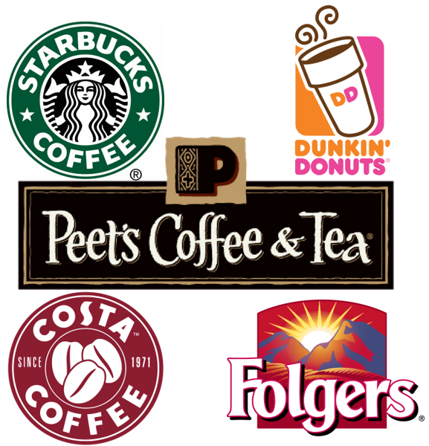

Figure 6 – Top - 5 coffee brands.  
Source: https://www.globalbrandsmagazine.com/best-coffee-brands-in-the-world/

Starbucks was founded in 1971 in Seattle, Washington. The brand is known to everyone due to their aggressive marketing and shrewd advertising techniques. The brand is not famous for sourcing and roasting the best coffee beans. Most of their coffee beans are dark-roasted, which means they taste bitter. Many consumers who know their coffee complain that Starbucks' coffee has a distinctly burnt taste. However, the company finds this to be acceptable. Starbucks knows that regular consumers like caffeine. Their coffee contains a lot of it. Also, Starbucks keeps coming up with blended and modified versions of its coffee. Through regular tasting panels, the company knows how much needs to be refined to target the average consumer. In addition, Starbucks gives consumers plenty of options to choose from. According to official sources, the company does offer gourmet coffee, however, it may not be the kind of coffee that consumers drink on a daily basis. Furthermore, the company is trying to be eco-friendly. They're introducing more plant-based food options, moving away from single-serve cups and trying to do a better job of managing their waste

As for Dunkin' Donuts, it was founded in 1950 in Canton, Massachusetts. Dunkin' is not as big a brand as Starbucks, but it has the second largest number of stores worldwide. The coffee that Dunkin' offers is certainly slightly better than Starbucks. For example, Dunkin' does not have the signature burnt flavor in its coffee that Starbucks does. Also the coffee is cheaper. The key difference between the two companies is that Dunkin' is more like a traditional coffee shop, while Starbucks is a premium coffee shop with a large selection of coffee that can be customized to consumers' tastes and chosen from an extensive menu. Also, at Dunkin', customers can sometimes get free donuts.

Concerning Costa Coffee, which was established in 1971 at London, United Kingdom. Costa coffee is one of the largest coffee chains in Britain. Having its presence in more than 31 countries worldwide, it has more than 3000 outlets serving coffee with around 18 thousand branches in the whole world. Costa coffees are medium roasted, which makes them smoother, sweeter, and nuttier.

As to Peet's coffee, which was founded in 1966 at California, United States. Peet's coffee is said to be fairly stronger than the coffee Starbucks serves so it might not be for everyone. Peet's has a long history of serving darker roasted Arabica coffee. The coffee supposedly has a variety of flavors. If you are someone who cannot stand the burnt taste in coffee, maybe you will like Peet's. Also, the store layout is traditional and the brand maintains a good relationship with its supply chain (aka, the farmers).

Regarding Folgers, it was introduced in 1850 in the United States. Folgers is one of the most iconic coffee brands in the United States. The brand is well known for their ground coffee and is thought to have revolutionized the idea of it as well. A unique brand of coffee which is widely recognized is Folgers. This enterprise was established during 1850 in the state of California. They have maintained to create a recognizable and memorable slogan: “The best portion of getting up is Folgers into your cup! Under the mid-20th century leadership of his great-grandson Peter Folger the brand became one of the principal coffee concerns in the world’s largest coffee market, North America. The coffee is not extraordinary in its taste, maybe mediocre at best. But, if brewed properly, you can get a modest cup of coffee. Besides, if you cannot afford anything better, Folger's is not bad at all.

**Types of coffee**

There are two most common types of coffee. The most produced type of coffee is Arabica. It accounts for approximately 70% of global production. The second main variety — Robusta, occupies about 30% of the market. Arabica is more demanding to the soil and climate and grows in higher mountainous areas. The optimal height for growing Arabica is considered to be 2000-2200 meters above sea level. Ecuador is considered the highest mountain region for growing Arabica. Robusta is not so whimsical in cultivation; this variety can grow well at an altitude of up to 700 m. The main suppliers of Robusta can be considered India, Africa and other tropical regions of our planet. Robusta is more complex than Arabica in its composition: it has more caffeine, and therefore it is more often used for making strong drinks and mixtures. This variety is distinguished by its low price.

**The coffee roast level**

The following in about the coffee roast level, which is shown on the Figure 6 below. The degree to which coffee beans are roasted is one of the most important factors that determine the taste of the coffee in the cup. Before roasting, green coffee beans are soft, with a fresh “grassy” smell and little or no taste. The coffee roasting process transforms these raw beans into the distinctively aromatic, flavorful, crunchy beans that we recognize as coffee. Other factors also determine the taste of coffee. Two coffee varieties, from different countries of origin or grown in different environments, are likely to taste quite different even when roasted to the same level (especially at light to medium roast levels). The age of the coffee, the processing method, the grind, and the brewing method will also affect the taste. But the roast level provides a baseline, a rough guide to the taste you can expect.

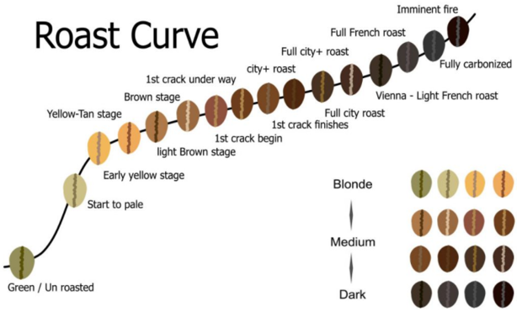

Figure 6 – Roast level.

Source: http://diagramreels.gisbertovalori.it/diagram/copper-roasting-diagram

The most common way to describe the level of coffee roasting is the color of the roasted beans, ranging from light to dark (or extra dark). As coffee beans absorb heat during the roasting process, their color becomes darker. Oils appear on the surface of the beans at higher temperatures. Because coffee beans differ, color is not a particularly precise way of assessing roasting. But in combination with a typical roasting temperature, which gives the beans a special shade of brown, the color is a convenient way to categorize the roasting level. Figure 7 shows the color of the roasted beans and it description.

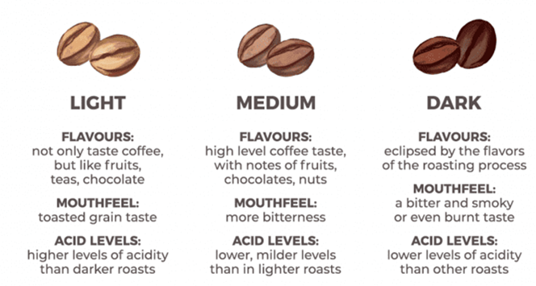

Figure 7 – Coffee beans color.

Source: https://www.pinterest.com/

Light roasted coffees are typically light brown in color, with no visible oils on the surface of the beans. These coffees typically have a crisp acidity, a mellow body, and bright, fruity or floral flavors and aromas. Lighter roasts preserve and highlight the origin flavors of the coffee beans. Such coffees are commonly referred to as Light, Cinnamon or Blonde roasts. Some ultra-light roasted coffees can have an unpleasant grassy or toasted grain taste with a pronounced acidity and tea-like consistency and body. This is typically a result of inadequate roasting time or finishing the roast at too low of a temperature (generally below about 395 degrees, up to or right at first crack), which can prevent full flavor development of the beans.

Medium roasted coffees are medium brown in color and rarely have an oily surface. These coffees generally have a medium acidity and body, as well as a well-rounded, balanced flavor profile. Roasting to this level typically preserves many of the unique flavors of the coffee’s origin, while bringing out the coffee’s deep caramel sweetness. These coffees are commonly referred to as Medium, American or City Roast.

Dark roasted coffee can be dark brown to nearly black in color and often have an oily surface. These coffees have a low acidity, heavy body, and tend to reveal deeper, darker flavors. Coffees roasted to this level tend to not have many of their origin characteristics left. Some coffees lend themselves very well to a deep roast highlighting their chocolatey, nutty, and/or caramel flavors. At this roast level, the flavors and aromas of the roasting process become more pronounced, and the taste of the coffee may be somewhat smoky. Dark roasted coffees are commonly referred to as Full-City, Vienna, French Roast or Italian Roast.

Preferences for the level of roasting are subjective. The level of roast you like may depend on where you live. In the United States, West Coast residents traditionally prefer darker roasts than East Coast residents. Europeans also prefer darker roasts, called the so-called French, Italian, and Spanish roasts, which dominate the darker part of the roasting spectrum.

**Coffee imports**

The main coffee importers are shown on the Figure 8. Interestingly, if we talk about which country's residents drink coffee the most, then the leaders will be Europeans. The average resident of Finland buys 9.6 kg of coffee a year, Norway — 7.2 kg, Holland — 6.7 kg. For comparison, in India and China — only 0.1 kg. In the countries of the former USSR, this indicator averages about 1 kg: Belarus-0.6 kg, Russia-1.2 kg, Ukraine-1.4 kg. The values in US$ are shown in the Table 1.

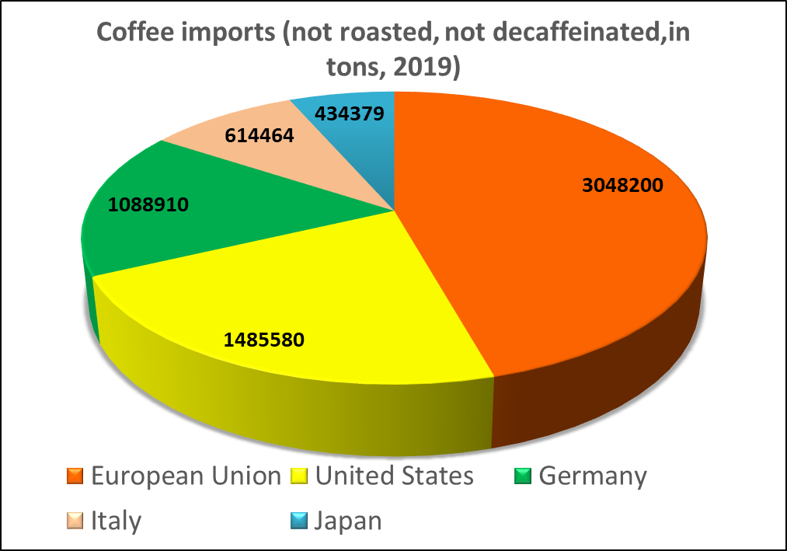

Figure 8 – Coffee imports.

Source: https://wits.worldbank.org/trade/comtrade/en/country/ALL/year/2019/tradeflow/Imports/partner/WLD/product/090111

Table 1. Coffee imports in monetary terms (not roasted, not decaffeinated, 2019)

|  |  |
| --- | --- |
| Importer | Trade Value mil US$ |
| EU | 6979,4 |
| US | 4383,2 |
| Germany | 2414,5 |
| Italy | 1360,0 |
| Japan | 1139,5 |

Source: https://wits.worldbank.org/trade/comtrade/en/country/ALL/year/2019/tradeflow/Imports/partner/WLD/product/090111

Figure 8 and Table 1 were created by the authors based on data from WITS.

**Coffee exports**

Further, Figure 9 and Table 2 show the top five exporters of not roasted and not decaffeinated coffee. So, as we can see first place is taken by Brazil, second by Colombia and third by Vietnam and in the Table 2 we can see amount of coffee exported in million US dollars. On the Figure 8 we can find exported coffee in tons.

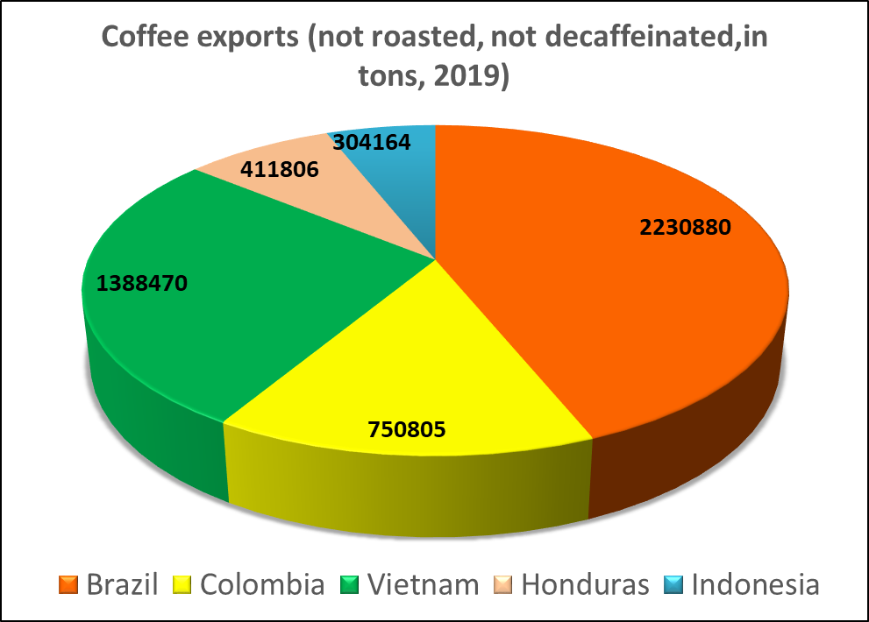

Figure 9 – Coffee exports.

Source: https://wits.worldbank.org/trade/comtrade/en/country/ALL/year/2019/tradeflow/Exports/partner/WLD/product/090111

Table 2. Coffee exports in monetary terms (not roasted, not decaffeinated, 2019)

|  |  |
| --- | --- |
| Exporter | Trade Value mil US$ |
| Brazil | 4575,001 |
| Colombia | 2279,9 |
| Vietnam | 2135,1 |
| Honduras | 954,7 |
| Indonesia | 872,4 |

Source: https://wits.worldbank.org/trade/comtrade/en/country/ALL/year/2019/tradeflow/Exports/partner/WLD/product/090111

Figure 9 and Table 2 were created by the authors based on data from WITS.

**The coffee value chain**

Figure 10 shows the coffee value chain is shown. Since the shelf life of roasted coffee beans is not too long, roasting should be carried out near the regions where coffee is consumed. Until recently, there were no packaging and distribution technologies to preserve the quality and taste of roasted grains. Technological progress in this area was slow. Because of this, it was difficult for roasting companies from producing countries to export their roasted grains around the world. Therefore, it is common for producing countries to export green coffee as an intermediate commodity in the value chain, while mixing and roasting is done in importing countries.

Traditionally, in the coffee value chain, the main role is played by the buyer and most of the value is created by roasters, large retailers and brands. These are the participants of the final stage of the chain. They set quality standards and production standards for all other industry participants.

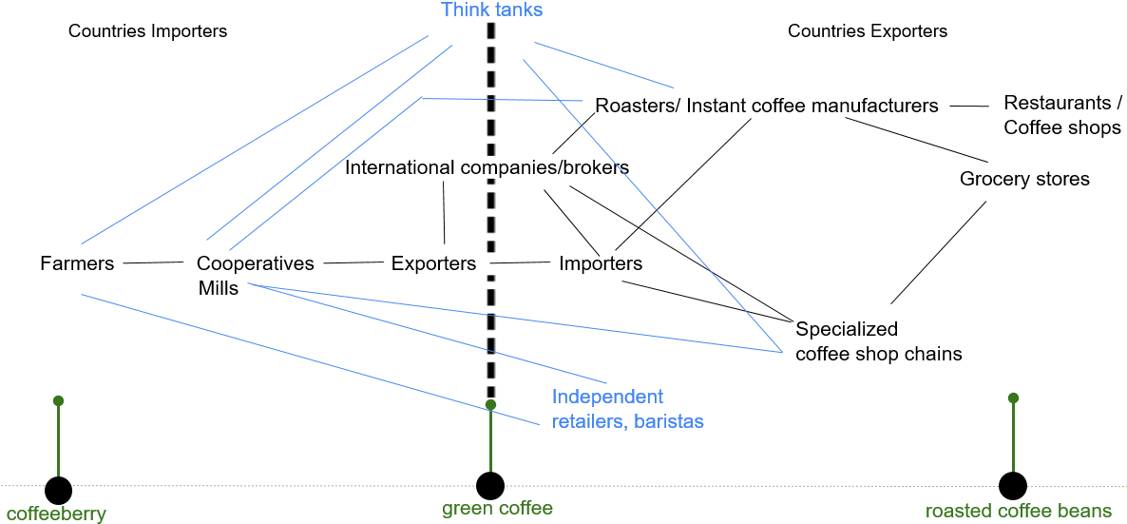

Figure 10 – The coffee value chain.

Regarding coffee transportation, it usually ships from the manufacturer raw. It is processed in the consumer country. Coffee beans are transported in bags. For ground coffee, cans or bags formed in wooden or cardboard boxes are used as packaging. Most often, delivery from the country of origin to consumers is carried out by sea vessels. When transporting such a special cargo, special storage rules must be observed, which ensure sufficient air circulation, effective removal of evaporating moisture and the exclusion of product contact with metal structures. Road transport, air transport, railway transport, and multimodal transport are also used.

**Worldwide coffee consumption**

So, the next Figure 11 presents statistics on coffee consumption. It is represented in million 60kg bags. According to this figure, we can see that coffee consumption has increased by almost 10 million 60kg bags since 2013. Compound annual growth rate is 1.80 %. This indicator shows us the mean annual growth rate of a coffee consumption over a specified period.

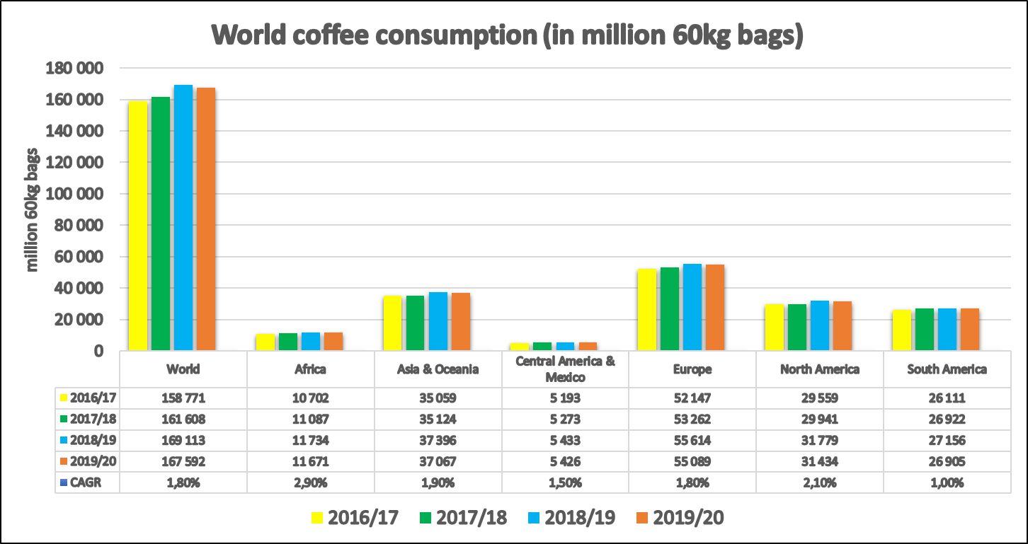

Figure 11 – World coffee consumption.

Source: http://www.ico.org/prices/new-consumption-table.pdf

Figure 11 was created by the authors based on the data from the ICO database.

**Coffee on the stock exchanges**

Figure 12 and Figure 13 show that coffee is listed on the New York Commodity Exchange, London Futures Exchange and on others commodity/futures exchanges. There is no single sector for the coffee industry, and coffee-related stocks can be found both in the [consumer discretionary](https://www.investopedia.com/terms/c/consumer-discretionary.asp) and [consumer staples](https://www.investopedia.com/terms/c/consumerstaples.asp) sectors. In general, retailers and coffee shops are part of the consumer discretionary group, and producers and packaged food companies are part of the consumer staples group. Best Value Coffee Stocks are presented on the figures below.

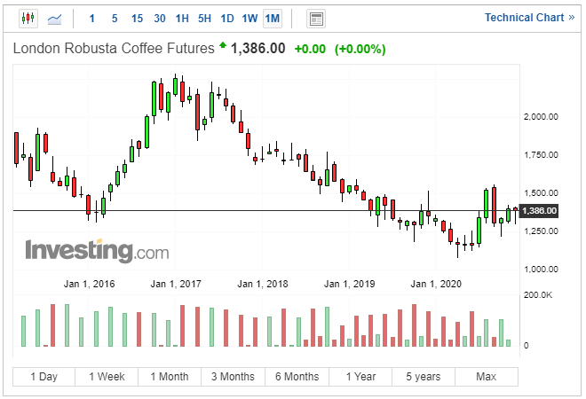

Figure 12 – Coffee futures.

Source: https://www.investing.com/commodities/london-coffee

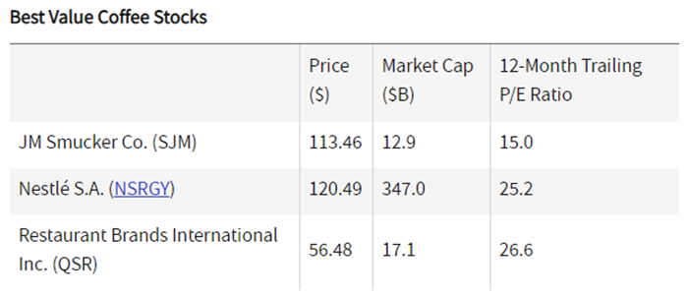

Figure 13 – Best value coffee stocks.

Source: https://www.investing.com/commodities/london-coffee

The coffee market is under the patronage of International Coffee organization (ICO) is an intergovernmental association that includes governments of different States, not companies or individuals. The ICO is designed to control and regulate world prices and maintain an appropriate balance in the global coffee industry in order to avoid any crises. Russia became the 74th member of the ICO and had observer status before joining. The International coffee agreement is based on the relationship between export volumes and market prices. The global export quota is distributed annually by the International Coffee Council and consists of two parts-an unchangeable part (70% of the quota) and a variable part (30%). However, since coffee is traded on the stock exchange, prices for products are constantly changing, which often leads to unpleasant consequences. The current period of historically low Arabica prices due to a record crop in Brazil is causing difficulties for many coffee farmers.

**Profit distribution**

Regarding profit allocation on the market, the approximate average farm prices per pound of green coffee reported by the International Coffee Organization (ICO) for the 2015-16 production year were $1.19 in Colombia, $1.25 in Costa Rica and $0.88 in Honduras. In fact, it is very difficult to say exactly how much farmers earn, because their profits depend on the harvest, weather conditions, staff and equipment maintenance costs etc.

As for the coffee sales on the stock exchange, we can look at the values for the last 3 years, for 2020 the average price was $1.11, for 2019 it was $1.02 and for 2018 it was $1.14. So the approximate average price is just over $1. This all prices are mentioned per pound of green coffee.

Retail prices of importing countries for roasted coffee between 2004 and 2017 ranged from $2 to $18 per pound, depending on the countries.

Coffee distributors as a coffee shop make approximately about $3,600 in profit at $12/lb if they sell 300 pounds per month. We can also look at other types of distributors, using the U.S. as an example:

According to the survey, coffee shops make in estimated annual revenue:

1. Espresso catering: $35,500.
2. Coffee kiosk: $75,000.
3. Mobile Coffee Truck: $145,000.
4. Drive-thru coffee stand: $165,000.
5. Brick-and-mortar Coffee Shop: $260,000.
6. Full Coffee shop & bakery: $310,000.
7. Cafe & bar: $360,000.
8. Coffee Shop, bar and kitchen: $430,000.

But these annual revenue numbers depend on their location, hours of operation, and sales volume. In reality, answering these questions is much more difficult. In addition, the costs associated with delivering revenue (operating expenses) are important factors in a coffee shop owner's takeout salary or profit margin.

Below, Figure 14 shows coffee imports during The Great Recession to see if this had a negative impact on the coffee market. Also, in the Table 3 you can see values expressed in US$. So, as we can see from the data and the graph, coffee exports during the recession period even increased, and in general from 2007 to 2014 it was within almost the same values. So we can conclude that the recession did not negatively affect exports on this market.

Table 3. Coffee imports values expressed in mill US$(not roasted, not decaffeinated).



Source: https://wits.worldbank.org/trade/comtrade/en/country/ALL/year/2019/tradeflow/Imports/partner/WLD/product/090111

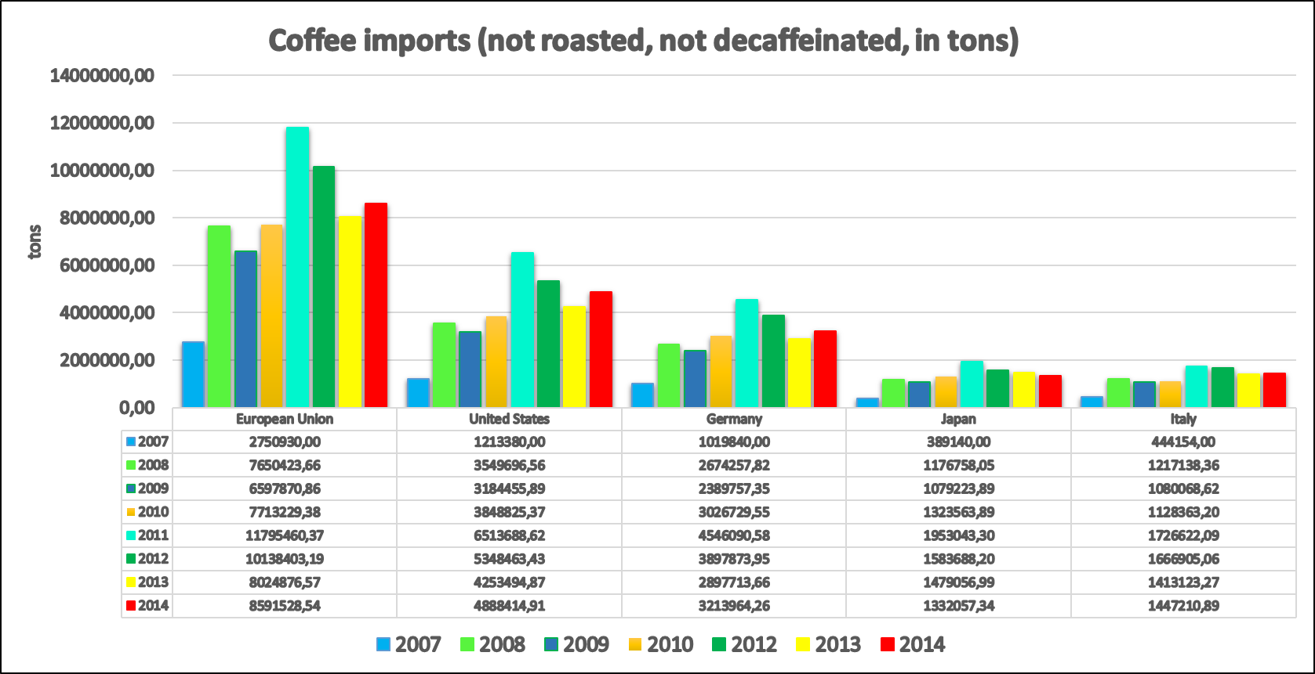

Figure 14 – Coffee imports.

Source: https://wits.worldbank.org/trade/comtrade/en/country/ALL/year/2019/tradeflow/Imports/partner/WLD/product/090111

Regarding exports during this period, which is shown on the Figure 15 and in the Table 4, all values were also about the same, except Vietnam, it had a huge drop in coffee exports in 2011.

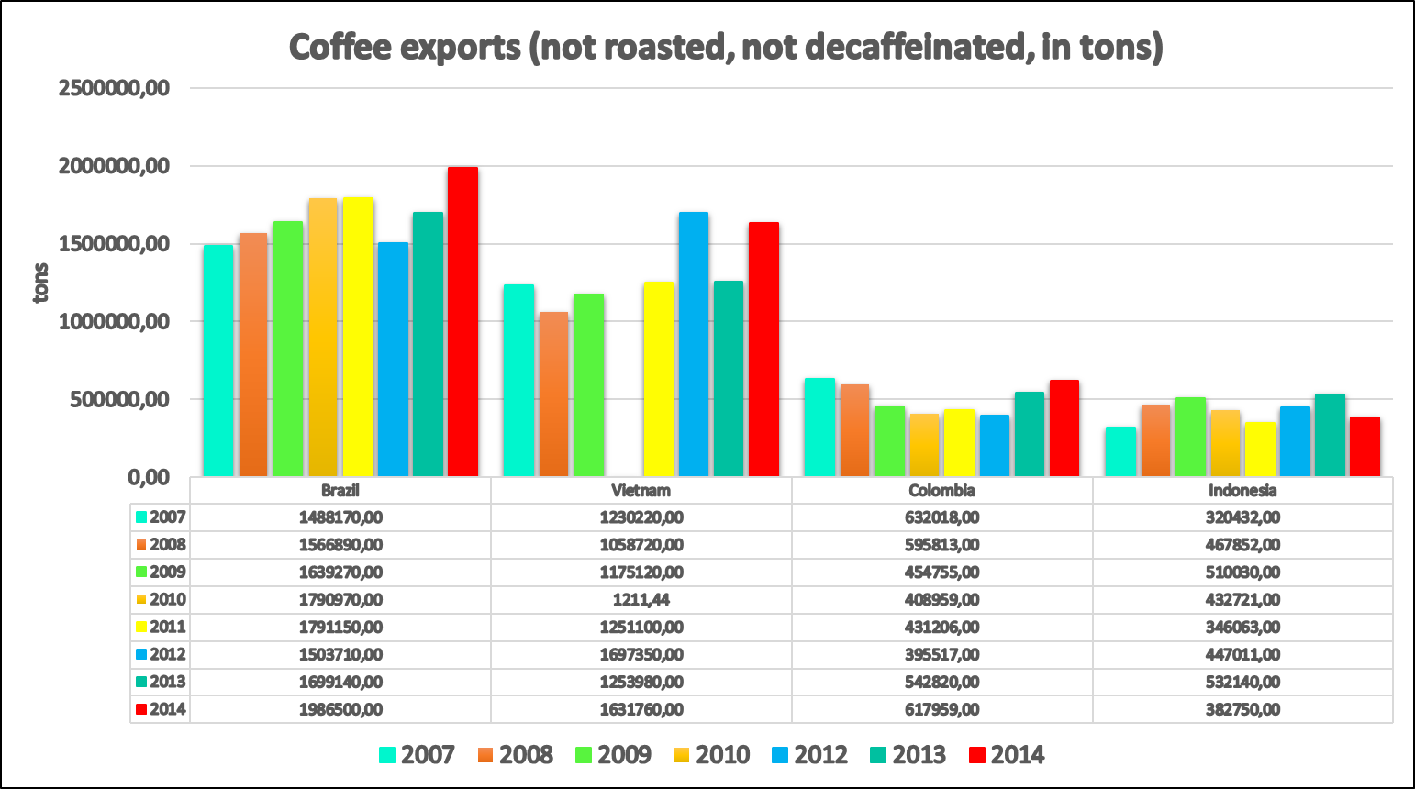

Figure 15 – Coffee Exports.

Source: https://wits.worldbank.org/trade/comtrade/en/country/ALL/year/2019/tradeflow/Imports/partner/WLD/product/090111

Table 4. Coffee exports values expressed in mill US$(not roasted, not decaffeinated).



Source: https://wits.worldbank.org/trade/comtrade/en/country/ALL/year/2019/tradeflow/Imports/partner/WLD/product/090111

Figures 14 and 15, Tables 3 and 4 were created by authors and based on data from WITS database.

Looking at Figure 15, which depicts that Vietnam has a very huge decline in coffee exports, it has been associated with that 2011 saw a steady stream of political trials and arrests as the government stepped up suppression of dissent in advance of the 11th Communist Party congress in January 2011.

**History of the growth of the Vietnam coffee production**

It would be interesting to look at the history of Vietnam's growth in the coffee market. In record time, Vietnam was able to go all the way to the world's second largest coffee producer and the absolute leader in the production of Robusta. What is the reason for the phenomenal rise? Vietnam's coffee history began because of the colonialists. In the mid-19th century, the French brought the first coffee trees to Vietnam. And by the end of the 19th century, the first plantations were organized. The best coffee has taken root in the plateaus and mountains of Central and southern Vietnam.

The middle of the 20th century was a difficult period in the General history of Vietnam and in the history of the country's coffee production. A series of unsuccessful anti-colonial uprisings, the Japanese occupation during world war II, the war of liberation against the French colonial administration, the creation of two separate States in the North (DRV, Democratic Republic of Vietnam or North Vietnam) and the South (Vietnam), the protracted war of 1957-1975, well known for direct us intervention in the internal Affairs of the two Vietnamese States. The destructive actions of the world superpower are still visible in many parts of Vietnam: the jungles were burned with orange, the rivers were poisoned with poisons, and people were destroyed by incessant bombing. Coffee production was severely disrupted. In 1975, the total area under coffee remained at about 20 thousand hectares with an annual production of 5000-7000 tons of green coffee.

During 1994-1999, the price of Robusta coffee rose, which again and again prompted Vietnamese producers to increase production. This was achieved in an extensive way – through an increase in acreage, which grew annually by 59% in the period from 1995 to 200025. Even during the period of a sharp decline in world coffee prices in 1999-2004, 26 when it seemed necessary to reduce the area of planting, Vietnam continued to increase the territory. The total area of coffee land by 2000 was 500,000 hectares, and annual production reached the level of 700 thousand tons. Thus, only in the 25 years since the formation of the unified state of Vietnam, the country's coffee industry has grown 100 times in production and increased the area by 25 times.

**Key market challenges: climate, pests, labor and price fluctuations**

Further, considered the coffee market in terms of the key challenges. The first challenge is climate change. Producers have no power over changes in the environment, but when their harvest suffers as a result, they do too. Currently, climate change is leading to rising temperatures and new rainfall patterns – something that’s placing the Arabica coffee species under threat because it is more sensitive to temperature increase, which reduces its growth, ability to flower, and consequent ability to produce fruit.

Second challenge concerns pests, diseases, and fungi which have become a real threat for many producers. Coffee leaf rust (la Roya) is one of the most famous diseases, and has been affecting coffee crops for over a century. In 2012, it hit Central America hard. And over the next two years, it caused over $1 billion in damage.

The third challenge is the lack of labor. The average age of a coffee producer is growing, and the numbers of them are decreasing. Children from coffee-producing families, seeing the struggles their families face, often choose to migrate to the city to find better opportunities.

The fourth one is price fluctuations because the commodity-grade price (C price) is based primarily on the NY Commodity Exchange. What’s more, due to these fluctuations, producers are unable to predict pricing trends and plan ahead.

**Conclusion**

Based on the entire research, several conclusions can be made:

1. Coffee sales have doubled in the last ten years.
2. The major supplier of coffee is Brazil. About 40% of global flows are from this country.
3. Arabica is the most popular type of coffee and it represents about 70% of world production.
4. Roast level preferences are subjective. The roast level you like may depend on where you live.
5. The main importer of coffee is the European Union. In 2019, it accounted for 3048200 tons of not roasted and not decaffeinated coffee.
6. Coffee consumption has increased by nearly 10 million 60 kg bags since 2013.
7. Compound annual growth rate is 1.80 %.
8. Stocks of coffee companies are traded on the stock exchange.
9. The coffee market is under the patronage of International Coffee organization (ICO).
10. In the 25 years since the formation of the unified state of Vietnam, the country's coffee industry has grown 100-fold in production and 25-fold in area.

**References**

1. BIBIUM. URL: https://bibium.com/bibium-infographics/bean-belt-infographic/
2. Universal Trade Zone (UTZ). URL: https://utz.org/better-business-hub/sourcing-sustainable-products/utz-coffee-program-remains-stable-in-2019-with-increased-demand/
3. Mordor Intelligence. URL: https://www.mordorintelligence.com/
4. My Health Gazette. URL: https://myhealthgazette.com/the-best-coffee-brands-in-2020
5. Global Brands Magazine. URL: https://www.globalbrandsmagazine.com/best-coffee-brands-in-the-world/
6. Diagram Database. URL: http://diagramreels.gisbertovalori.it/diagram/copper-roasting-diagram
7. Pinterest. URL: https://www.pinterest.com/
8. World Integrated Trade Solutions (WITS). URL: https://wits.worldbank.org/trade/comtrade/en/country/ALL/year/2019/tradeflow/Imports/partner/WLD/product/090111
9. World Integrated Trade Solutions (WITS). URL: https://wits.worldbank.org/trade/comtrade/en/country/ALL/year/2019/tradeflow/Exports/partner/WLD/product/090111
10. International Coffee Organization. URL: http://www.ico.org/prices/new-consumption-table.pdf
11. Financial Platform Investing.com URL: https://www.investing.com/commodities/london-coffee